Money-makers
SASE SD WAN
Maximise new margin-rich revenue streams

Solutionize with EXPO.e

As part of the EXPO.e Channel community, we can help elevate your business by combining our expertise, experience, and evolving portfolio with your own, opening the door to new service innovations and margin-rich new revenue streams.

Why Expo-e
We’re a UK pioneer in Cloud, Connectivity, Unified Communications, and Cyber Security, with more than twenty years’ experience enabling other organisations to grow, innovate, and drive positive change. Here’s what we can do for you.

01
Grow your Portfolio
Combine our services with your own, including multiple solutions not available anywhere else.

02
Enjoy platinum-level support
From off-the-shelf solutions to sophisticated bespoke ones, you’ll enjoy the highest standard of support.

03
Accelerate your business growth
Military-grade solutions – resilient, low-latency, and highly secure – to achieve your goals faster.

04
Maximise your uptime
Our enterprise-class network ensures your customers can always access your services, wherever and whenever they are needed.

06
20 years of excellence in the Channel
Partnering with EXPO-e you benefit from both our technical capabilities, and our deep experience as a solution enabler across the Channel.

05
Utilise your governance
Stop saying ‘no’ to your ideal projects and retain business with the public sector through our accreditations, certification and frameworks.

Collaboration, consultation and community
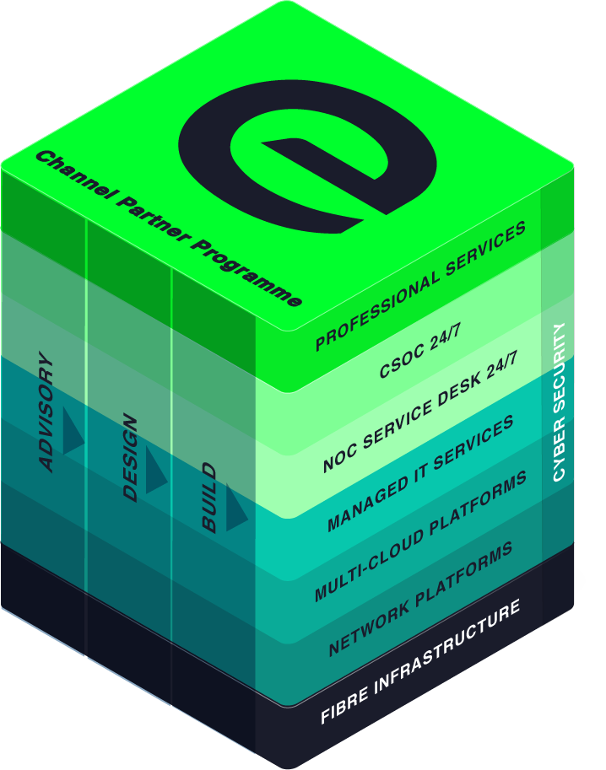
We cultivate partnerships built on collaboration and consultation, that empower our Channel community to bring tomorrow’s innovations to life today, even for contracts they’d have previously been unable to fulfil.
Whatever the size of your organisation, the sector you operate in, and your ideal customers, we are here to help you achieve your full potential - not only bringing your products and solutions to market, but helping you transform interested prospects into longstanding, repeat customers.

Margin-rich Money-makers – SASE & Software Defined WAN
Resilience, availability, and security, with bespoke, enterprise-grade connectivity.
SASE & SD-WAN
We live in an interconnected world, where highly available, always on services are the norm. This means enterprise-grade connectivity that is affordable, scalable, and flexible, with the highest standards of resilience and data protection - even for modern, perimeter-less networks, is required.
The EXPO.e Channel Ecosystem puts this new breed of connectivity right at your fingertips, ready to deploy whenever and wherever your customers require it. above is a bit

How it works
EXPO.e’s connectivity portfolio brings together a comprehensive range of leading-edge solutions, designed, delivered, and managed by leading experts, supported by robust SLAs, and built on our self-owned, enterprise-class network.
The result is optimal control and scalability, reduced operational costs, and an accelerated path to the Cloud, with the highest standard of cyber security inherent in the design of every solution.
An industry-leading SD-WAN solution  Drawing on EXPO.e’s years of experience as a UK pioneer in software-defined connectivity - delivered as a fully managed service. | Secure Access Service Edge (SASE)  Combining leading-edge networking and zero-trust cyber security in a Cloud-based solution, to provide optimal control, protection, and visibility.
Managed LAN and WiFi  Intelligent connectivity and a centralised, highly intuitive user interface, for maximum control and visibility. | 24 / 7 Support  Proactive support from EXPO.e’s own UK-based NOC.

Exceptional service quality is part of our DNA
Exceptional service quality is part of our DNA and has been for more than twenty years. That’s why we display our industry-leading Net Promoter Score (NPS) live on our website.
We don’t do tiers of service. Whether you are a Carrier, Reseller, or Referral partner, you are automatically a Platinum Partner.
Enable
- Make it easy to do business with Expo-e
- Deliver a consistent strategy enabling you and your teams to grow pipeline and win new business
- Listen to you and understand what we need to do to make your teams successful
Deliver
- Direct dial contacts to our provisioning coordinators with escalation points up to our Director of Service Delivery
- Weekly order trackers / provisioning calls
- Coming soon – live Partner dashboards
- Executive level relationships with all last mile providers
Support
- Fault, Find & Fix 24 x 7 x 365 UK support with 1st, 2nd & 3rd line engineers
- 24 x 7 Proactive monitoring, reporting back to you about customer service outages
- ITIL trained and ISO20000 compliant so you can be rest assured that you and your customers are in safe hands
Margin
- Move from 10% to 40% margins by expanding your solution offering and adding more value
- Maximise profits by delivering better business outcomes for your customers
- Increase retention by helping customers overcome more challenges

This is what good looks like

Anyone can deliver technology, but it's people that really make the difference. That's the difference between a service provider and a partner, and that's what we've enjoyed throughout our relationship with EXPO.e.
Terry Faria
Telecommunications Manager, Quiss Technology.

It's the shared values that have really been the foundation of our relationship with EXPO.e, as well as their willingness to do things a bit differently.
Robb Thaw
Product Marketing Manager, Natilik.

We’ve increased individual client revenue FIVE FOLD by adding EXPO.e’s Cloud services to our portfolio.
Stephen Harte
Head of Technology, Opus Technology.

