Money-makers
S4 Object Storage
Maximise new margin-rich revenue streams

Solutionize with EXPO.e

As part of the EXPO.e Channel community, we can help elevate your business by combining our expertise, experience, and evolving portfolio with your own, opening the door to new service innovations and margin-rich new revenue streams.

Why EXPO.e
We’re a UK pioneer in Cloud, Connectivity, Unified Communications, and Cyber Security, with more than twenty years’ experience enabling other organisations to grow, innovate, and drive positive change. Here’s what we can do for you.

01
Grow your Portfolio
Combine our services with your own, including multiple solutions not available anywhere else.

02
Enjoy platinum-level support
From off-the-shelf solutions to sophisticated bespoke ones, you’ll enjoy the highest standard of support.

03
Accelerate your business growth
Military-grade solutions – resilient, low-latency, and highly secure – to achieve your goals faster.

04
Maximise your uptime
Our enterprise-class network ensures your customers can always access your services, wherever and whenever they are needed.

06
20 years of excellence in the Channel
Partnering with EXPO-e you benefit from both our technical capabilities, and our deep experience as a solution enabler across the Channel.

05
Utilise your governance
Stop saying ‘no’ to your ideal projects and retain business with the public sector through our accreditations, certification and frameworks.

Collaboration, consultation and community
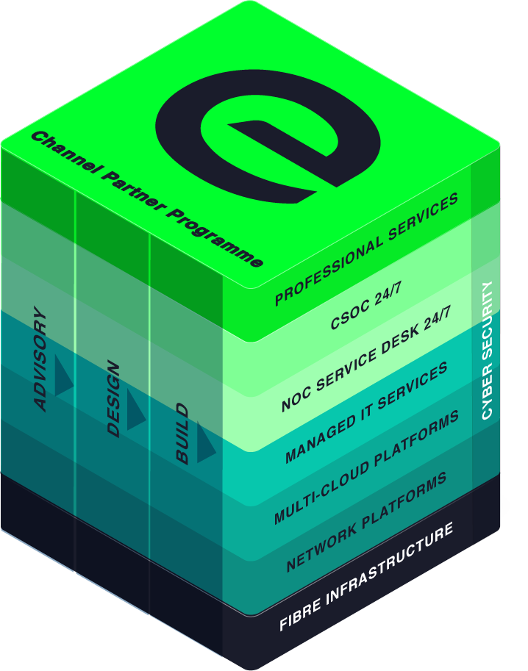
We cultivate partnerships built on collaboration and consultation, that empower our Channel community to bring tomorrow’s innovations to life today, even for contracts they’d have previously been unable to fulfil.
Whatever the size of your organisation, the sector you operate in, and your ideal customers, we are here to help you achieve your full potential - not only bringing your products and solutions to market, but helping you transform interested prospects into longstanding, repeat customers.

Margin-rich Money-makers – S4 Object Storage
As an EXPO-e Channel Partner, you will be able to play an active role in helping your customers move from treating data storage as an onerous financial burden, to a powerful source of future growth and innovation.
A leading-edge storage solution, offering optimal security, geo replication, and complete sovereignty for large, highly complex files, with cost reductions of 70% compared to similar platforms.
Simple
Storage can be complex. S4 simplifies administration through single namespace management and universal accessibility.
Secure
With data encrypted at-rest and in transit, S4 gives complete security, plus all the cost-efficiency and scalability benefits of multitenancy storage.
Scalable
Hardware-agnostic, Cloud enhanced scalability lets customers grow raw capacity while sustaining high-performance, on any infrastructure.
Sovereign
With S4, customers don’t have to worry about data sovereignty: data will never leave our UK-based, privately-owned Network and Data Centres.

How it works
S4 Object Storage brings the retention and management of the highest volumes of critical data into the Cloud, utilising a software-defined approach to combine the very highest standard of cyber security with scalability, cost control, and geo replication across multiple world-class data centres.
No additional bandwidth or egress charges  All billing is fully transparent, so your customers only pay for what they use. | Optimised for big data and AI projects  Help bring your customers’ big data and AI innovations to life, by providing them with the tools they need to manage and analyse their unstructured data at scale.
Effortless control & scalability  S4 Object Storage provides users with full control and visibility of their data through an intuitive online portal, offering trackability across two locations and the option of extending to a third data centre, if requested by the customer. | Leading-edge cyber security  The highest standard of data protection is inherent in the design of S4 Object Storage, with full encryption in transit and at rest, and support for both Object and HDFS protocols.
Complete data sovereignty  With access to EXPO.e’s world-class,  UK-based data centres, your customers’ data need never leave the country, significantly simplifying their compliance challenges. | Maximum operational resilience  Data replicated across geographically diverse locations, allowing restoration as quickly as possible, should it ever prove necessary.

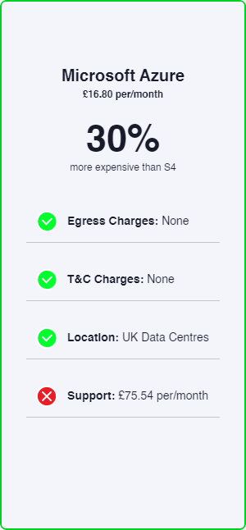
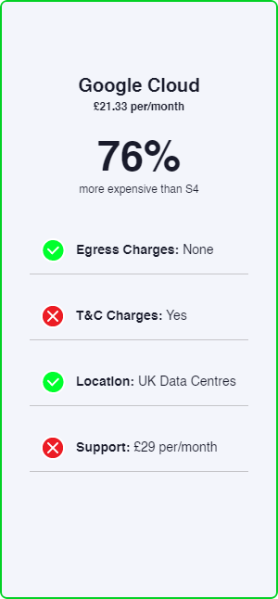
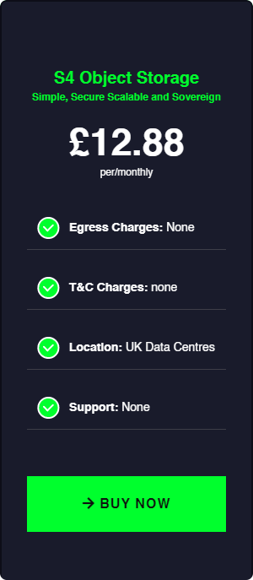
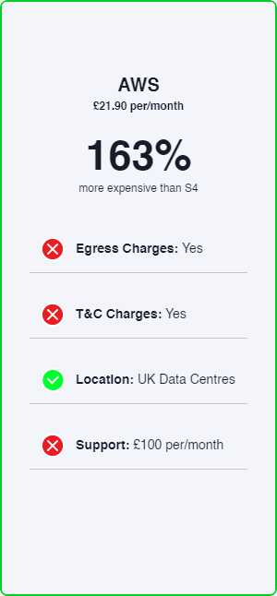
Tangible opportunities for you and your customers

Exceptional service quality is part of our DNA
Exceptional service quality is part of our DNA and has been for more than twenty years. That’s why we display our industry-leading Net Promoter Score (NPS) live on our website.
We don’t do tiers of service. Whether you are a Carrier, Reseller, or Referral partner, you are automatically a Platinum Partner.
Enable
- Make it easy to do business with Expo-e
- Deliver a consistent strategy enabling you and your teams to grow pipeline and win new business
- Listen to you and understand what we need to do to make your teams successful
Deliver
- Direct dial contacts to our provisioning coordinators with escalation points up to our Director of Service Delivery
- Weekly order trackers / provisioning calls
- Coming soon – live Partner dashboards
- Executive level relationships with all last mile providers
Support
- Fault, Find & Fix 24 x 7 x 365 UK support with 1st, 2nd & 3rd line engineers
- 24 x 7 Proactive monitoring, reporting back to you about customer service outages
- ITIL trained and ISO20000 compliant so you can be rest assured that you and your customers are in safe hands
Margin
- Move from 10% to 40% margins by expanding your solution offering and adding more value
- Maximise profits by delivering better business outcomes for your customers
- Increase retention by helping customers overcome more challenges

This is what good looks like

Anyone can deliver technology, but it's people that really make the difference. That's the difference between a service provider and a partner, and that's what we've enjoyed throughout our relationship with EXPO.e.
Terry Faria
Telecommunications Manager, Quiss Technology.

It's the shared values that have really been the foundation of our relationship with EXPO.e, as well as their willingness to do things a bit differently.
Robb Thaw
Product Marketing Manager, Natilik.

We’ve increased individual client revenue FIVE FOLD by adding EXPO.e’s Cloud services to our portfolio.
Stephen Harte
Head of Technology, Opus Technology.

