Money-makers
Managed Cyber Security Operations Centre
Maximise new margin-rich revenue streams

Solutionize with EXPO.e

As part of the EXPO.e Channel community, we can help elevate your business by combining our expertise, experience, and evolving portfolio with your own, opening the door to new service innovations and margin-rich new revenue streams.

Why EXPO.e
We’re a UK pioneer in Cloud, Connectivity, Unified Communications, and Cyber Security, with more than twenty years’ experience enabling other organisations to grow, innovate, and drive positive change. Here’s what we can do for you.

01
Grow your Portfolio
Combine our services with your own, including multiple solutions not available anywhere else.

02
Enjoy platinum-level support
From off-the-shelf solutions to sophisticated bespoke ones, you’ll enjoy the highest standard of support.

03
Accelerate your business growth
Military-grade solutions – resilient, low-latency, and highly secure – to achieve your goals faster.

04
Maximise your uptime
Our enterprise-class network ensures your customers can always access your services, wherever and whenever they are needed.

06
20 years of excellence in the Channel
Partnering with EXPO.e you benefit from both our technical capabilities, and our deep experience as a solution enabler across the Channel.

05
Utilise your governance
Stop saying ‘no’ to your ideal projects and retain business with the public sector through our accreditations, certification and frameworks.

Collaboration, consultation and community
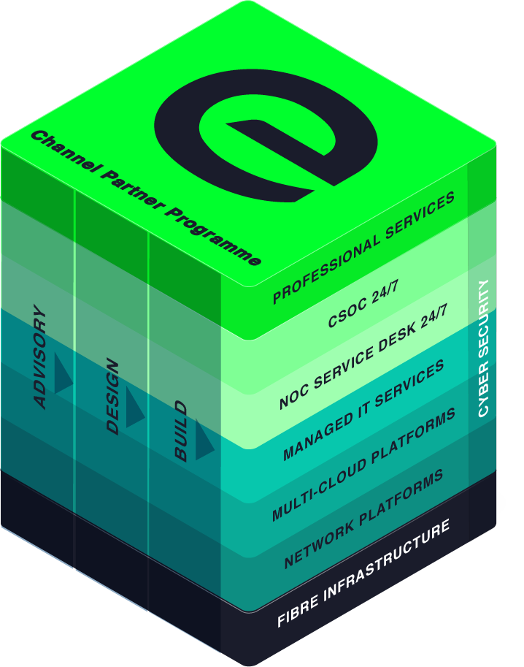
We cultivate partnerships built on collaboration and consultation, that empower our Channel community to bring tomorrow’s innovations to life today, even for contracts they’d have previously been unable to fulfil.
Whatever the size of your organisation, the sector you operate in, and your ideal customers, we are here to help you achieve your full potential - not only bringing your products and solutions to market, but helping you transform interested prospects into longstanding, repeat customers.

Margin-rich Money Makers – Managed Cyber Security Operations Centre
The first line of defence - 24/7 monitoring and alerting, to offer your customers complete peace of mind.In an escalating threat landscape, organisations at all levels are concerned about maintaining the integrity of their critical data. This, in turn, often leads to questions over the current level of internal cyber security expertise and the potential cost of upgrading and maintaining existing security ecosystems. As an EXPO.e Channel Partner, our managed CSOC allows you to alleviate these challenges, letting our cyber security experts take responsibility for the day-to-day management of their security ecosystems and ensuring any potential breach is dealt with straight away. This means you can offer them complete peace of mind, freeing them to focus on their own business operations and immediately establishing you as a critical technology partner.

Managed

CSOC

How it works
EXPO.e’s Managed CSOC allows your customers to take a proactive approach to cyber security while minimising the resulting burden on their own IT teams. EXPO.e’s fully certified cyber security experts work to identify any potential breaches and ensure the appropriate actions are taken. There are numerous elements to this, including:

Real-time cyber security monitoring
Operating 24 / 7 x 365 to proactively identify any potential threats and issue automatic alerts – all based on the very latest threat intelligence
The Unified Security Management (USM) Anywhere platform
Manage the entire security ecosystem through a fully centralized, highly intuitive platform.
An Advanced Persistent Database
Fully integrated with the security ecosystem, a comprehensive breakdown of the latest threats, updated by the end users.
Automated categorization of devices and assets
Streamline compliance with corporate cyber security policies

Exceptional service quality is part of our DNA
Exceptional service quality is part of our DNA and has been for more than twenty years. That’s why we display our industry-leading Net Promoter Score (NPS) live on our website.
We don’t do tiers of service. Whether you are a Carrier, Reseller, or Referral partner, you are automatically a Platinum Partner.
Enable
- Make it easy to do business with EXPO.e
- Deliver a consistent strategy enabling you and your teams to grow pipeline and win new business
- Listen to you and understand what we need to do to make your teams successful
Deliver
- Direct dial contacts to our provisioning coordinators with escalation points up to our Director of Service Delivery
- Weekly order trackers / provisioning calls
- Coming soon – live Partner dashboards
- Executive level relationships with all last mile providers
Support
- Fault, Find & Fix 24 x 7 x 365 UK support with 1st, 2nd & 3rd line engineers
- 24 x 7 Proactive monitoring, reporting back to you about customer service outages
- ITIL trained and ISO20000 compliant so you can be rest assured that you and your customers are in safe hands
Margin
- Move from 10% to 40% margins by expanding your solution offering and adding more value
- Maximise profits by delivering better business outcomes for your customers
- Increase retention by helping customers overcome more challenges

This is what good looks like

Anyone can deliver technology, but it's people that really make the difference. That's the difference between a service provider and a partner, and that's what we've enjoyed throughout our relationship with EXPO.e.
Terry Faria
Telecommunications Manager, Quiss Technology.

It's the shared values that have really been the foundation of our relationship with EXPO.e, as well as their willingness to do things a bit differently.
Robb Thaw
Product Marketing Manager, Natilik.

We’ve increased individual client revenue FIVE FOLD by adding EXPO.e’s Cloud services to our portfolio.
Stephen Harte
Head of Technology, Opus Technology.

