Money-makers
Disaster Recovery as a Service
Maximise new margin-rich revenue streams

Solutionise with EXPO.e

As part of the EXPO.e Channel community, we can help elevate your business by combining our expertise, experience, and evolving portfolio with your own, opening the door to new service innovations and margin-rich new revenue streams.

Why EXPO.e
We’re a UK pioneer in Cloud, Connectivity, Unified Communications, and Cyber Security, with more than twenty years’ experience enabling other organisations to grow, innovate, and drive positive change. Here’s what we can do for you.
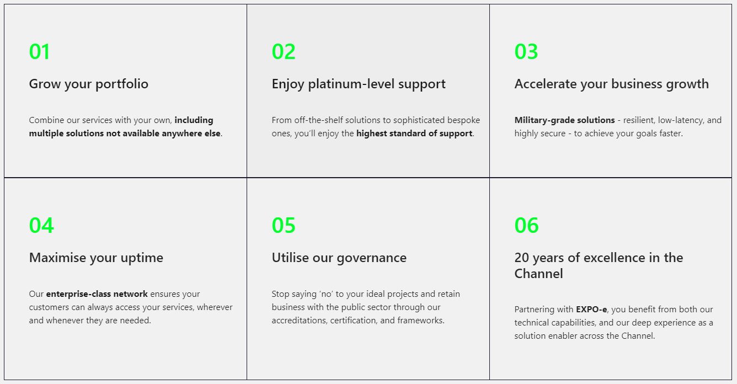

Collaboration, consultation and community
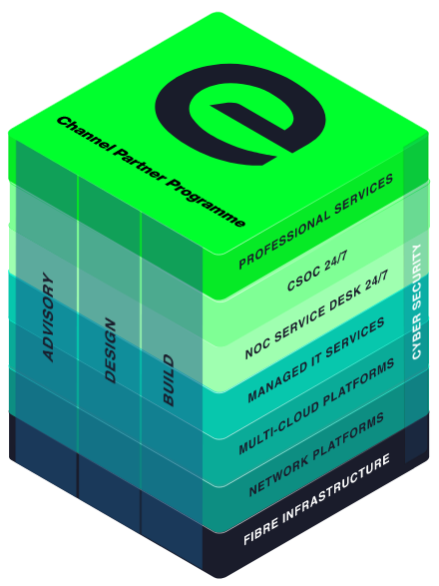
We cultivate partnerships built on collaboration and consultation, that empower our Channel community to bring tomorrow’s innovations to life today, even for contracts they’d have previously been unable to fulfil.
Whatever the size of your organisation, the sector you operate in, and your ideal customers, we are here to help you achieve your full potential - not only bringing your products and solutions to market, but helping you transform interested prospects into longstanding, repeat customers.

Margin-rich Money-makers – Disaster Recovery as-a-Service
Deliver optimal uptime, performance, or security by ensuring your customers’ mission-critical systems and applications can be fully restored in a matter of seconds, whenever necessary.

The combination of Zerto’s industry-leading technology with EXPO.e’s business-only network and deep technical expertise allows you to adopt a truly bespoke approach to DRaaS, delivering solutions tailored to each customer’s unique requirements and helping establish you as a key technology partner. At the same time, our ISO 27001 and ISO 22301 accreditations provide an extra level of reassurance and allow you to offer the most robust SLAs.

Disaster Recovery

as-a-Service

How it works
EXPO.e's DRaaS model encompasses offsite backup and replication for both physical and virtual systems, combining Zerto’s leading-edge software-defined replication & recovery automation technology with our self-owned, enterprise-class network - delivered as a fully managed service, so customers DR processes can run safely in the background until they need to be initiated. The result:
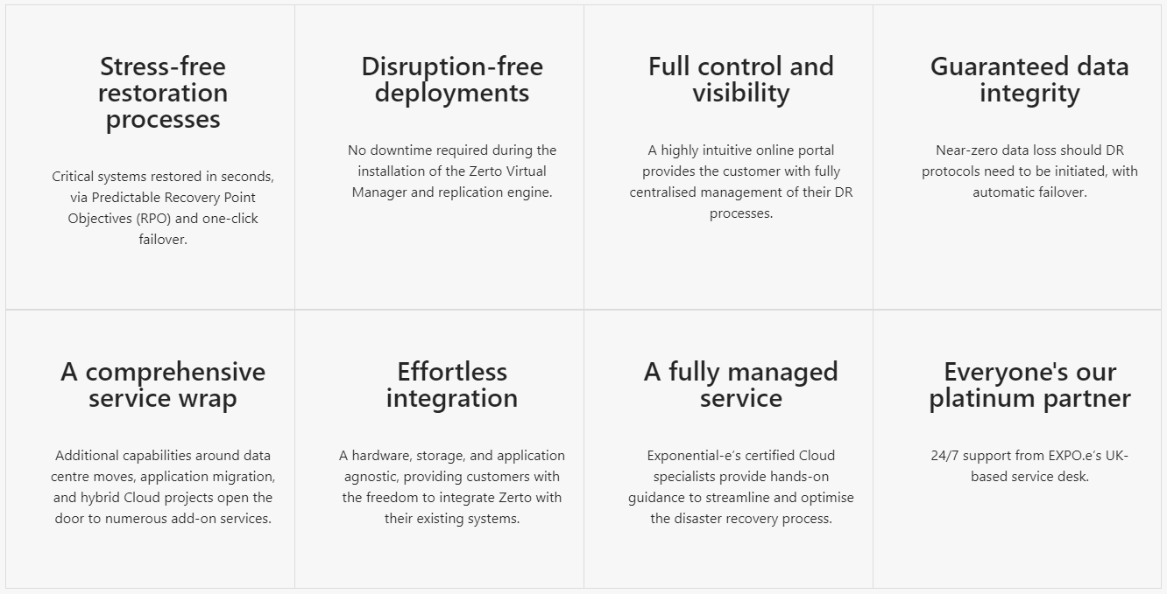

Exceptional service quality is part of our DNA
Exceptional service quality is part of our DNA and has been for more than twenty years. That’s why we display our industry-leading Net Promoter Score (NPS) live on our website.
We don’t do tiers of service. Whether you are a Carrier, Reseller, or Referral partner, you are automatically a Platinum Partner.
Deliver
- Direct dial contacts to our provisioning coordinators with escalation points up to our Director of Service Delivery
- Weekly order trackers / provisioning calls
- Coming soon – live Partner dashboards
- Executive level relationships with all last mile providers

Enable
- Make it easy to do business with EXPO.e
- Deliver a consistent strategy enabling you and your teams to grow pipeline and win new business
- Listen to you and understand what we need to do to make your teams successful

Margin
- Move from 10% to 40% margins by expanding your solution offering and adding more value
- Maximise profits by delivering better business outcomes for your customers
- Increase retention by helping customers overcome more challenges

Support
- Fault, Find & Fix 24x7x365 UK support with 1st, 2nd & 3rd line engineers
- 24x7 Proactive monitoring, reporting back to you about customer service outages
- ITIL trained and ISO20000 compliant so you can be rest assured that you and your customers are in safe hands
This is what good looks like

This is what good looks like

Anyone can deliver technology, but it's people that really make the difference. That's the difference between a service provider and a partner, and that's what we've enjoyed throughout our relationship with EXPO.e.
Terry Faria
Telecommunications Manager, Quiss Technology.

It's the shared values that have really been the foundation of our relationship with EXPO.e, as well as their willingness to do things a bit differently.
Robb Thaw
Product Marketing Manager, Natilik.

We’ve increased individual client revenue FIVE FOLD by adding EXPO.e’s Cloud services to our portfolio.
Stephen Harte
Head of Technology, Opus Technology.

