Sales Enablement Pack
Disaster Recovery as a Service
A truly bespoke approach to DRaaS

Server Replication (DRaaS) - Sales Enablement Pack

A truly bespoke approach to DRaaS

All-in one Disaster Recovery (DR) solution providing continuous data protection, enabling ongoing operations through any disruptive event, and delivering workload mobility. Ensure application availability and drive business continuity to minimise losses resulting from downtime with our Cloud-based solution.

What is Disaster Recovery as a Service

A data centre recovery solution designed to capture a point-in-time copy (backup) of an enterprise workload and write the data out to a secondary storage device for the purpose of recovering this data in the future.

This delivers the ability to recover or maintain IT systems in the event of outages or recover data from deletion or corruption.

Why is Disaster Recovery Important
- 33% of companies that have DR measures in place don’t test periodically to ensure these are working - not every company has the resources or knowledge to carry out these processes.
- Robust DR strategies support business growth - being able to demonstrate DR pedigree through certified processes helps your customer’s credibility, enabling them to win larger deals.
- 50% of smaller businesses do not survive a significant disaster event (e.g. ransomware, data breach etc.) In contrast, 96% of businesses with a DR practice in place do fully recover.
- 75% of small businesses have no DR plan in place - it may fall into the ‘nice-to-have’ category, that is, until they need to use it.

Market Information

Distributed Cloud is one of the top 10 Strategic Technology Trends for 2023.

Global Disaster Recovery as a Service (DRaaS) market expected to grow from $5.1Bin 2020 to $14.6B by 2025 (23.3% YOY increase).

Integrated Risk Management is one of top 20 emerging technologies and trends of H1 2023, amongst over 5000 others.

The average cost of IT downtime for businesses is about $5,600 per minute.

Challenges
- Money - Keeping copies of the same data in multiple locations leads to higher storage and processor costs.
- Time - Implementing and managing a data replication system requires dedicated time from an internal team.
- Bandwidth - Maintaining consistency across data copies requires new procedures and adds traffic to the network.
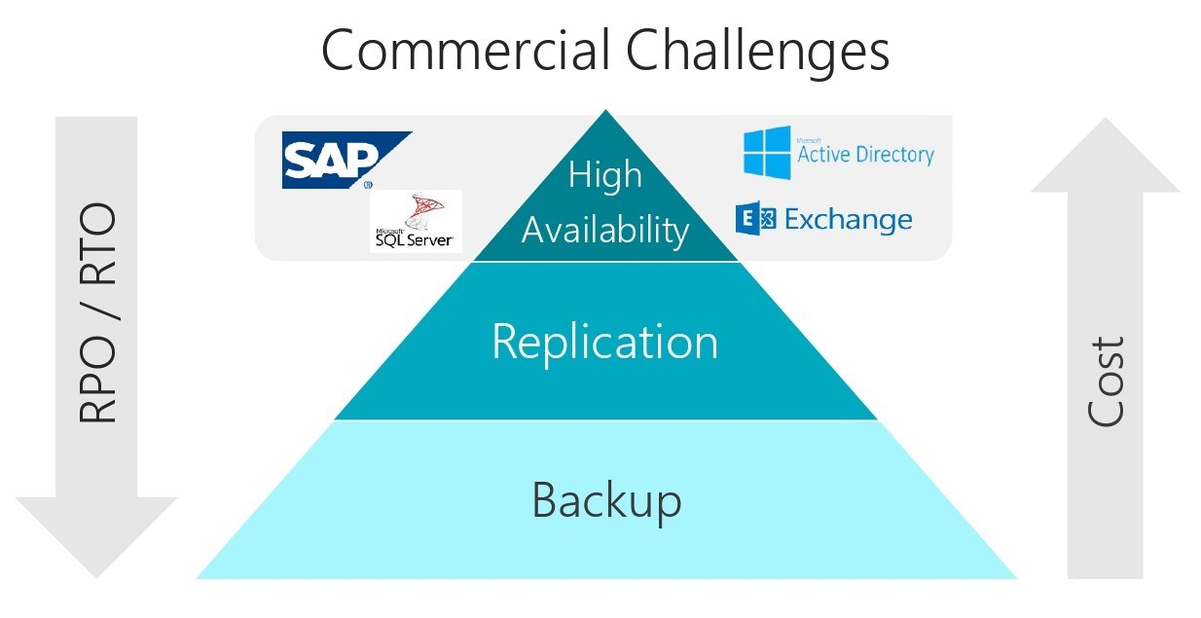

Why Expo-e for Disaster Recovery
- Experienced in delivering best-in-class DRaaS solutions across a variety of use cases and verticals - currently protecting thousands of VMs in our environment.
- Platinum partner of industry leaders in Data Centre Backup and Recovery solutions, Zerto, to deliver a comprehensive DRaaS solution backed by our private network.
- Certified Cloud specialists provide detailed Business Continuity Planning (BCP) to reduce the impact of any disruptive events on your customer’s business.
- Solutions are tailored to your individual customer’s needs through a solution and outcome based approach, starting with an in-depth initial consultation and full support and guidance along the journey from our experienced Cloud team
- Provide a complete Business Impact Assessment (BIA) to measure impact of disruptive events and determine a Recovery Time Objective (RTO) to mitigate customer impact.
- Expo-e have a demonstrable and certified DR process (ISO 27001, ISO 22301), experienced in working with customers of all sizes across multiple sectors including financial, legal, and healthcare.
- Low risk implementation and migration through our team of dedicated Cloud Solutions Consultants, Delivery Experts, and our 24x7 UK Support Desk
- Fully managed service where we manage the infrastructure to reduce yours and your customer’s touch time and administrative burden on in-house resource.
- Complementary services available to provide more strategic DR/BC solutions including private networking, WAN, SDN/SD WAN, and Cyber Security - all protected under a single SLA when buying through Expo-e.
- Provides a single point of contact across all services enabling vendor consolidation and simplifying access to support for your customers.
- Multiple public cloud environments managed under our Cloud Management Platform (CMP) for the entire replicated estate.

Features & Benefits
Quick Recovery and Failback: Our existing service offers up to 4 hours recovery time as standard: Your customers can benefit from the ability to failback to a point in time beyond this with 7, 14, and 28 day journaling options.
Full Service Management: You and/or your customers can have access to our UK Service Desk 24/7x365 with a pre-agreed invocation plan in place, focused around your customer’s dependencies and business priorities, to streamline the recovery process so your customers can focus on matters outside of the IT estate in a DR scenario.
Enhanced Protection: A consistent high-bandwidth connection is key for seamless replication. Leverage our private, enterprise network to deliver this service onto your customer’s existing network by allowing them to extend their server subnets from their locations into our VDC for a true end-to-end solution.
Cost Savings: Cloud-based solution removes up-front physical hardware costs associated with legacy infrastructure and provides the flexibility to scale resources as required. Your customers only pay for VMs once spun up in DR which reduces costs as they are not paying for unused resources.
No Performance Impact: Other replication technologies use snapshotting which has a performance impact at the VM level. Ours works at the hypervisor layer, replicating across to the target storage seamlessly, ensuring there is no service degradation or performance impact on your customer workloads.
Easy Isolated Testing: With our service, we offer a free yearly DR test and can provide your customers with a sandbox IP subnet isolated where they can perform functional testing without impact to the production environment. Live failover tests can also be performed with minimal disruption.
Flexibility: Your customers have the option to replicate from a single VM to their entire estate. Set up Virtual Protection Groups (VPGs) in a cascading order to prompt business critical servers to failover first. Provides a boot order recovery process in an automated manner.

What is One-to-Many (O2M)
- One-to-Many feature allows a VM to simultaneously replicate to several other target locations while replicating a local copy.
- Simultaneously protect applications, VMs, and data - locally and to multiple remote sites - from logical failures, human errors, and malware attacks.
- Continuous data protection, point in time recoverability, with RPOs of seconds enable rapid, local or remote recovery - which can now be retrieved from seconds before the deletion or corruption.

Product Options
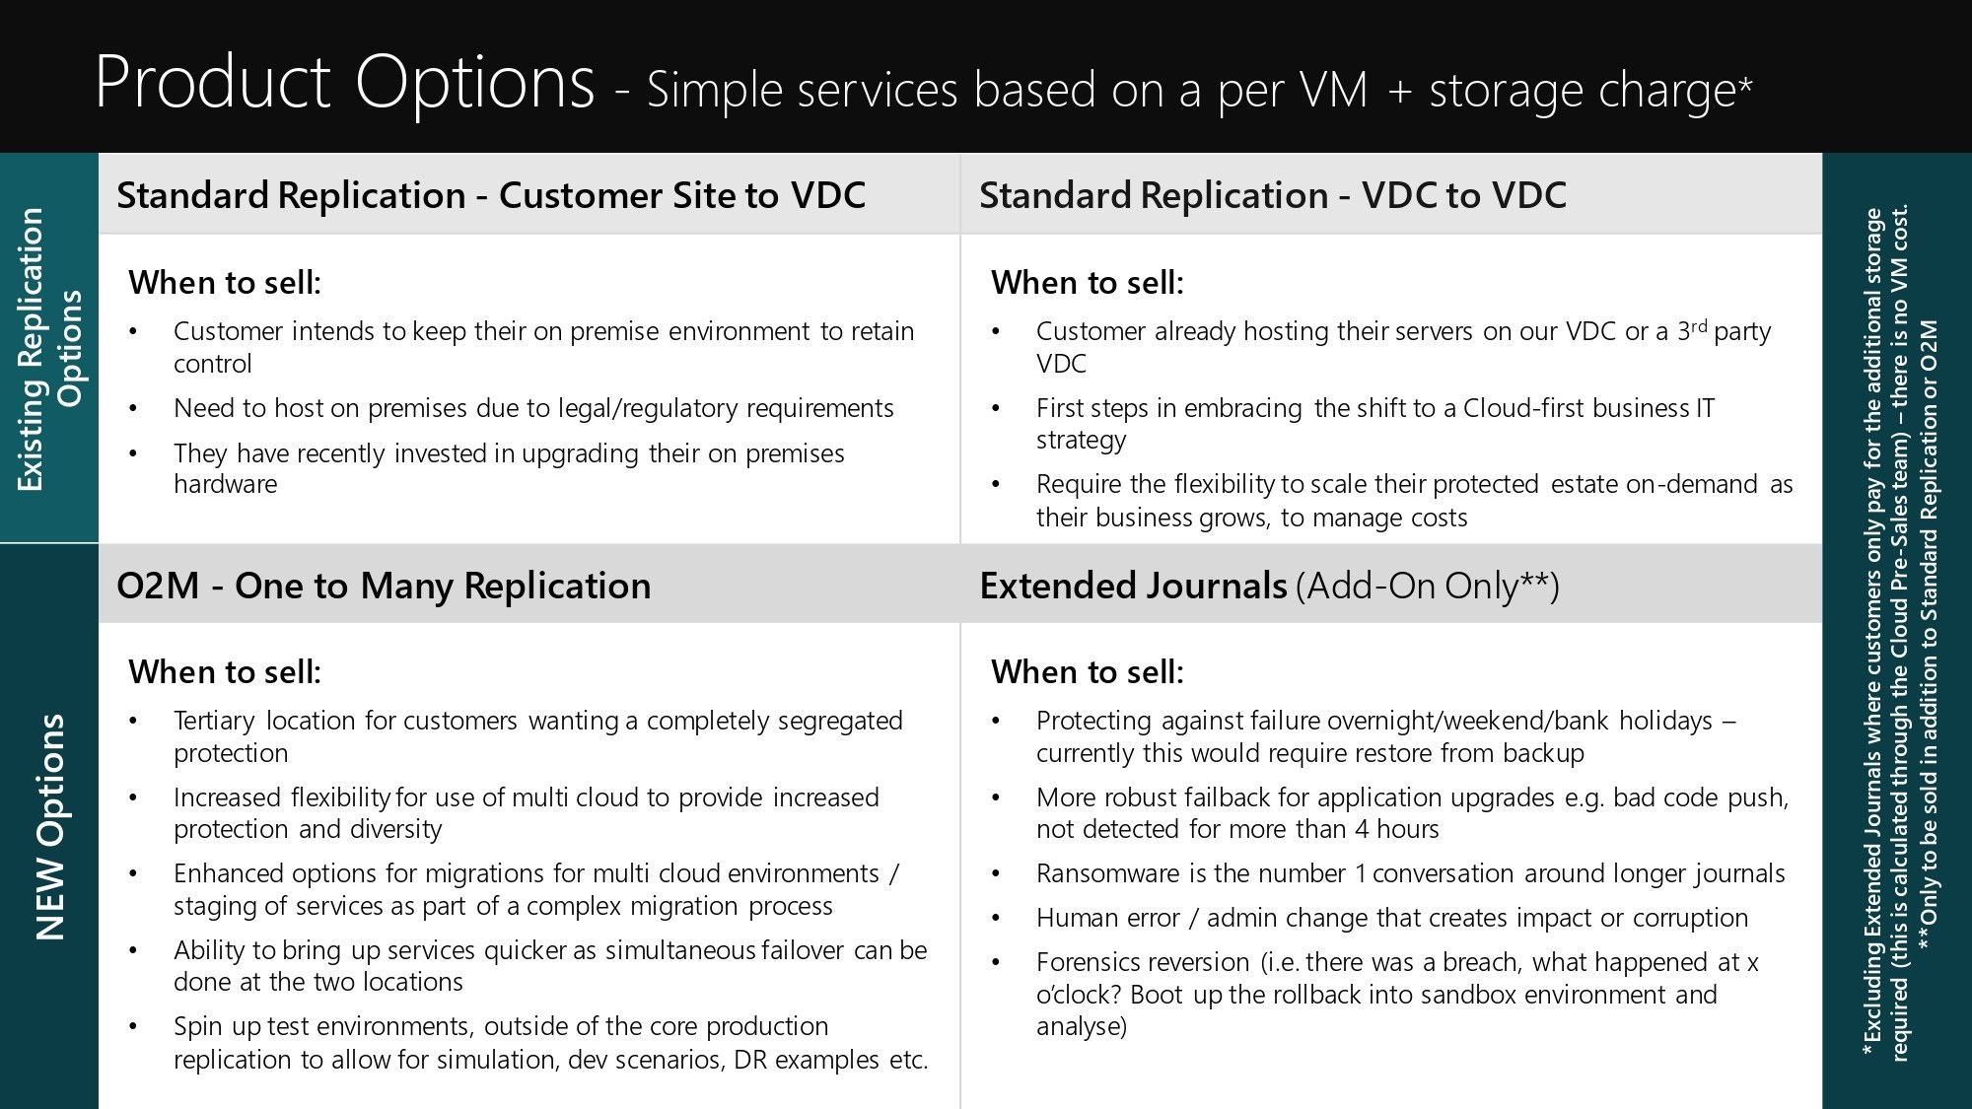

*Need to confirm this is OK for external view?

Use Cases
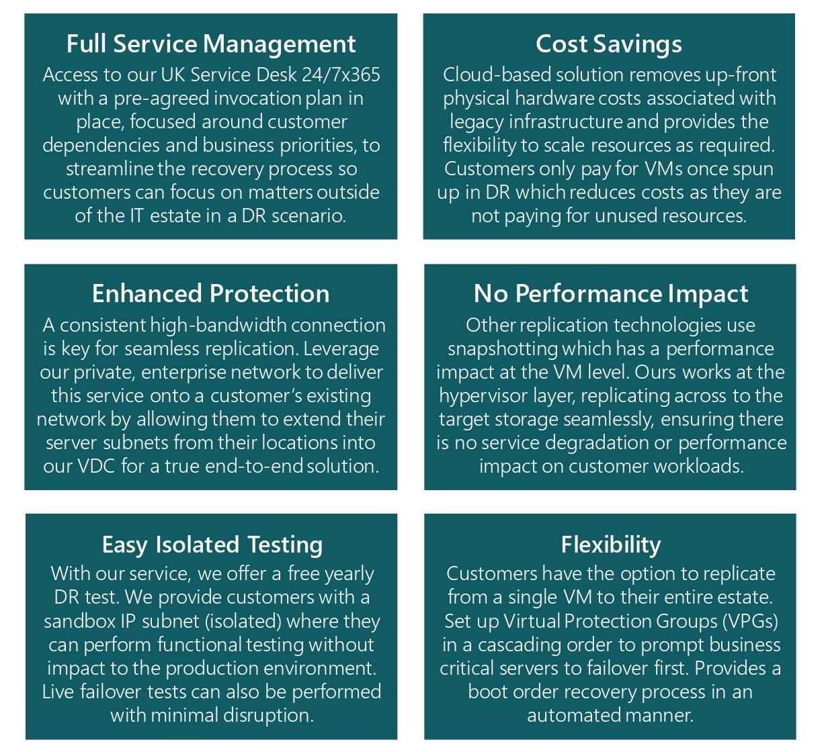

*This needs to be slightly reworded to say ‘your’ customers

Discovery questions to ask your customer
- Do you know when your organisation last carried out any form of DR test?
- What team, or who would be responsible for that within the organisation?
- What’s the process for a DR test today? (What tech is used?)
- Do you know if it was deemed a success? (How do you measure success?)
- How often do you carry out a full DR test? How long does it take and how many people are needed?
- Do you know if the business has specific RPOs & RTOs that they are looking to achieve? (What do they achieve today?)
- What would happen today if the business was down for 4 hours, what sort of impact would that have?
- What amount of downtime and data loss is acceptable to your business? (Tangible & Intangible costs of
- Were the SLA’s set based on what your business needs or the best that IT can deliver?
- Do you tier your servers and applications against importance/criticality?
- How do you protect your critical applications today?
- Do your business applications consist of multiple VM’s and if so, how do you manage application consistent recovery?
- Do you have a specific team that would monitor, protect and recover against a Ransomware attack?
- Do you have internal Ransomware training?
- What would be the current recovery process from a ransomware attack (it is not if, but when)?
- How do you manage applications during technology refresh programs?
- How do you carry out migrations?
- How do you mitigate against vendor lock in?
- How do you create copies of production environments to carry out patch testing, upgrades, and/or pen testing?
- What is your cloud strategy over the next 3 years?
    - Private, Public, Hybrid
    - Consolidation of current DCs

Qualification questions to ask your customer
- Focus the conversation on the overall BC/DR strategy.
    - Single points of failure?
- What is their current DR practice?
    - Does it work?
    - Can they test it?
    - Do they have confidence in it?
- Do they have compliance requirements to meet? (e.g. FCA obligations)
- What is the cost of disruption? How much money is the business losing when critical systems are offline?
- Every business needs DR try to articulate the cost of IT disruption.
    - Fee earners cost per minute?
    - Regulated industries fines and penalties?
- If they are running VMWare, which version (i.e. vSphere/vCentre)?
- If they are running hyperV, which version? Must also be running system centre virtual machine manager (SCVMM)?
- Do you have any raw device mappings RDM or in guest iSCSI mapping?
- What number of VM do you need to replicate and what storage is assigned?

Qualification Metrics
What key metrics do Presales need to know from the onset to scope out a customer solution?
- Number of Servers?
- Total amount of VM Storage (GB/TB) to be protected?
- Customer location and connectivity?
- Which Hypervisor they are using (e. VMWare)?
- Existing RTOs and RPOs they need to adhere to?

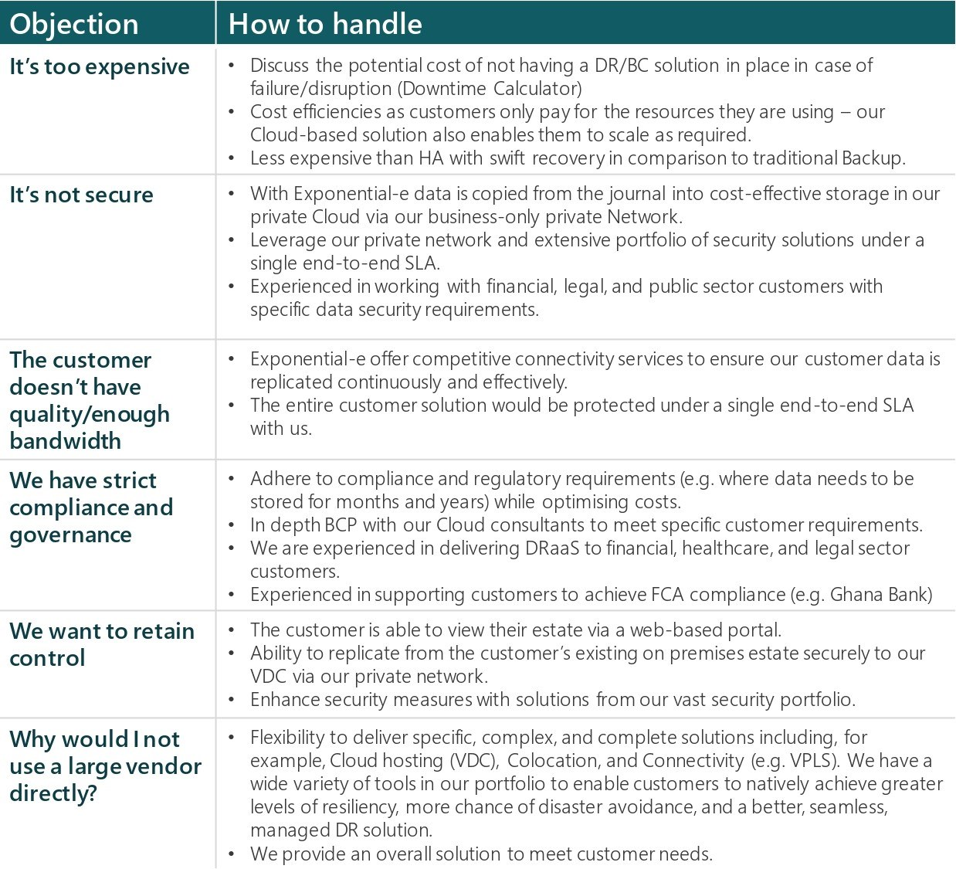
Objection Handling

*This will need to be slightly reworded for Channel. Exponential-e needs to be changed to Expo-e

