Sales Enablement Pack
S4 Object Storage
Simple, Secure, Scalable and Sovereign

S4 Storage - Sales Enablement Pack

Simple, Secure, Scalable and Sovereign
Our S4 Cloud Storage solution simplifies storage for traditional as well as next-generation workloads, with global access and protection.
It is a multi-purpose, software-defined object storage managed solution that will take businesses to the next level and lower operational costs with unmatched storage efficiency, resiliency and simplicity.

What is S4 Cloud Storage
- Cloud Storage technologies have been designed with a view to assisting with the management of files. Instead of being split, files are written to disk as a single object, with a physical address to aid with retrieval.
- Object storage is an approach to storage where data is combined with rich metadata in order to preserve information about both the context and the content of the data, making it easier to describe and manage the information contained therein.
- Cloud Storage is perfect upsell for Cloud deployments, allowing capacity and resilience to be increased simply by adding new nodes and making it easy to deploy objects across a distributed system, simplifying remote access and high availability.
- Expo-e's solution brings the simplicity and scale of Cloud services to anyone. Our S4 solution is accessible in the same way as Public Cloud object storage, and it is optimised for workloads that have unique data access requirements, such as Cloud and Big Data.

Why S4 Cloud Storage
- Scalability: Object Storage uses a structurally flat data environment that removes the complexity and scalability challenges of a hierarchical file system with folders and directories, and the system scales out by simply adding nodes.
- Offload objects: Object Storage offloads objects (files, media, images) from computer resources, reducing load on server resources.
- Universal Accessibility: S4 supports Object, NFS, and HDFS workloads on a single platform to meet the broadest range of application needs and to simplify development.
- Cost-effective: Object Storage is not only affordable, but also reduces the operational costs associated with maintaining legacy data storage infrastructure.
- Durability: By combining 3N redundancy, intelligent data placement, automatic recovery of lost or corrupted objects and automated handling of drive failures, Object Storage provides extremely high levels of durability when compared to conventional storage options.
- Data Lake / Big Data: S4 provides scalability and security, enabling your customers to consolidate unstructured data into a highly efficient and flexible Data Lake and a foundation for Big Data analytics.
- Data Protection: Geo-protection provides enhanced protection against site failures. S4 also implements mirroring and erasure coding to avoid single points of failures.

Market Information
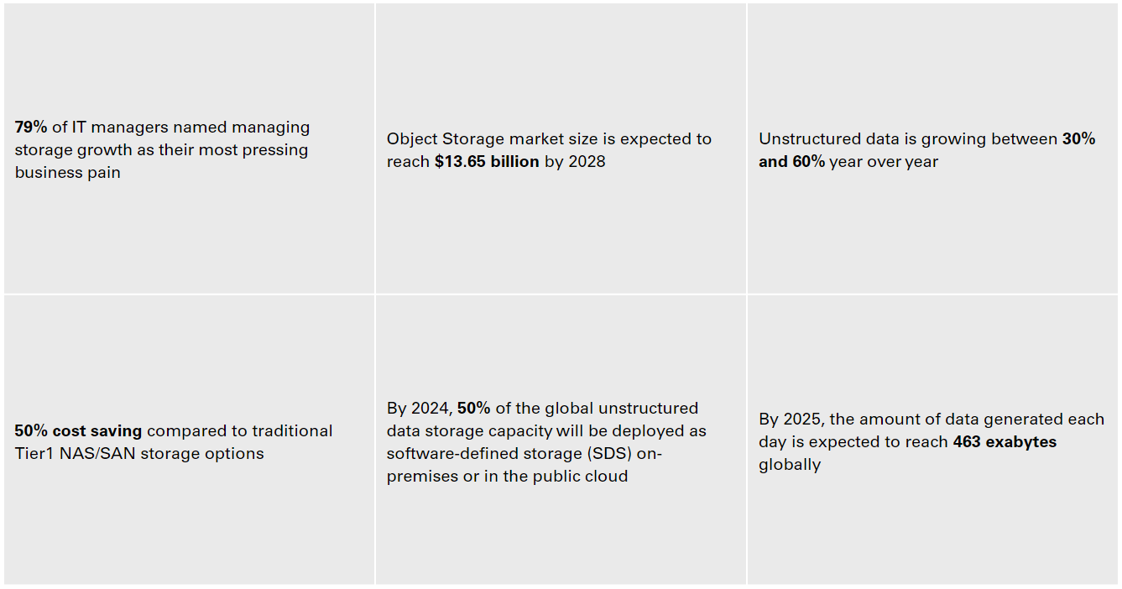

Challenges
- The nature of data has been changing, the amount of unstructured data collected by digital services and new applications – email, video, images, web-pages, IoT sensors – is growing and it requires an appropriate storage solution.
- The rate at which data is generated is increasing and conventional storage techniques aren’t designed to handle petabytes of data.
- Hierarchical file systems can have performance delay when managing large quantities of data.
- Traditional block or file storage becomes expensive and difficult to manage when the quantity of data grows too much too quickly.
- Collecting and storing information is crucial to modern Big Data programs, as well as the ability to retrieve and manage that data effectively.
- Traditional storage and disk drives come with the possibility of data loss, and when trying to retrieve something it might return just a part of it.

Why Expo-e for S4 Storage
Cloud Storage Platform: Expo-e will provide your customers with access to our Cloud Storage platform deployed across our three Cloud nodes in the UK. The platform is a fully managed, fully hosted Cloud solution and as such your customer will not need to budget for the hosting and management.
True guaranteed UK sovereignty end-to-end: With our S4 service, your customer’s data will never leave our UK-based, privately-owned Network and Data Centres.
Transparent pricing: No egress charges or support charges will be added to the final cost, when integrated into your customer’s VPLS
Peace of mind: We provide world-class 24/7x365 customer service and we are highly accredited with 9 ISOs. We offer Peace of Mind Service, with the best people and best technology behind everything we do.
Partner Relationship: Through the deployment of Dell EMC’s Elastic Cloud Storage (ECS) across all of our Tier 3 UK-based Data Centres, and combined with our superfast private Cloud Connectivity, we can provide access to low-cost storage.
Turnkey Solution: We provide an End-to-End solution that covers Connectivity, Storage, Archive + Backup, Big Data Analytics, and access to a full portfolio of managed services, supported by dedicated Sales Specialists, Solutions Consultants and Delivery Experts.

Features & Benefits
Storage Gateway – Object storage provides the back-end target for unstructured data, keeping it available while offering the best possible performance.
Transparent pricing - S4 has no egress charges or support charges, allowing transparency and better budgeting for your customers.
Geographic redundancy - S4 is natively available across two geographic locations, with the ability to extend the solution to a third data centre, ensuring maximum data availability.
Data Replication - Cloud Storage helps reduce the number of points of possible failure in the platform, preventing catastrophic data loss.
Unlimited scale-out flexibility - S4 supports unlimited workloads and applications with geographic protection, detailed metering and a self-service management portal, allowing your customers to easily scale based on their requirements and removing the complexity of capacity management.
Self-Healing - Automatic identification of failed drives and replication of data to preserve 3N redundancy.
Comprehensive high-performance accessibility - S4 supports both Object and HDFS protocols on a single, globally-accessible, highly-available platform.
Big Data performance - S4’s HDFS data service makes the entire storage solution available for Big Data analytics and information-based application environments.
‘Internet of Things’ data-analytics - Supporting unstructured data collection and analysis at massive scale, S4 makes IoT data analytics a production reality for organisations of any size.
Application deduplication & redundancy – Ensures the highest level of data availability whilst reducing the cost and management of on-premises storage solutions.
S3 compatibility – Our S4 solution allows your customers to use hundreds of existing Amazon S3-compatible applications via the Expo-e S3-compatible API.
Wide support for developer languages and frameworks - Simple, secure access using almost any language or framework including .NET, Java, C, Flex, PHP, Python, Ruby and JavaScript.
Manual or automated data transfer – Your customers can manually upload data or to use a range of automated solutions, such as EMC Networker, CommVault or Riverbed.

Product Offering
Secure
With data encrypted at rest and in transit, S4 gives complete security, plus all the cost efficiency and scalability benefits of multitenancy storage
Scalable
Hardware agnostic, Cloud enhanced scalability lets your customers grow raw capacity while sustaining high-performance, on any infrastructure

Sovereign
With S4, your customers don’t have to worry about data sovereignty: data will never leave our UK based privately owned Network and Data Centres
Simple
Storage can be complex. S4 simplifies administration through single namespace management and universal accessibility

*Wondering if Marketing can make the above section more interesting with the 4 new ‘ball’s’?
automatically a Platinum Partner.

Use Cases
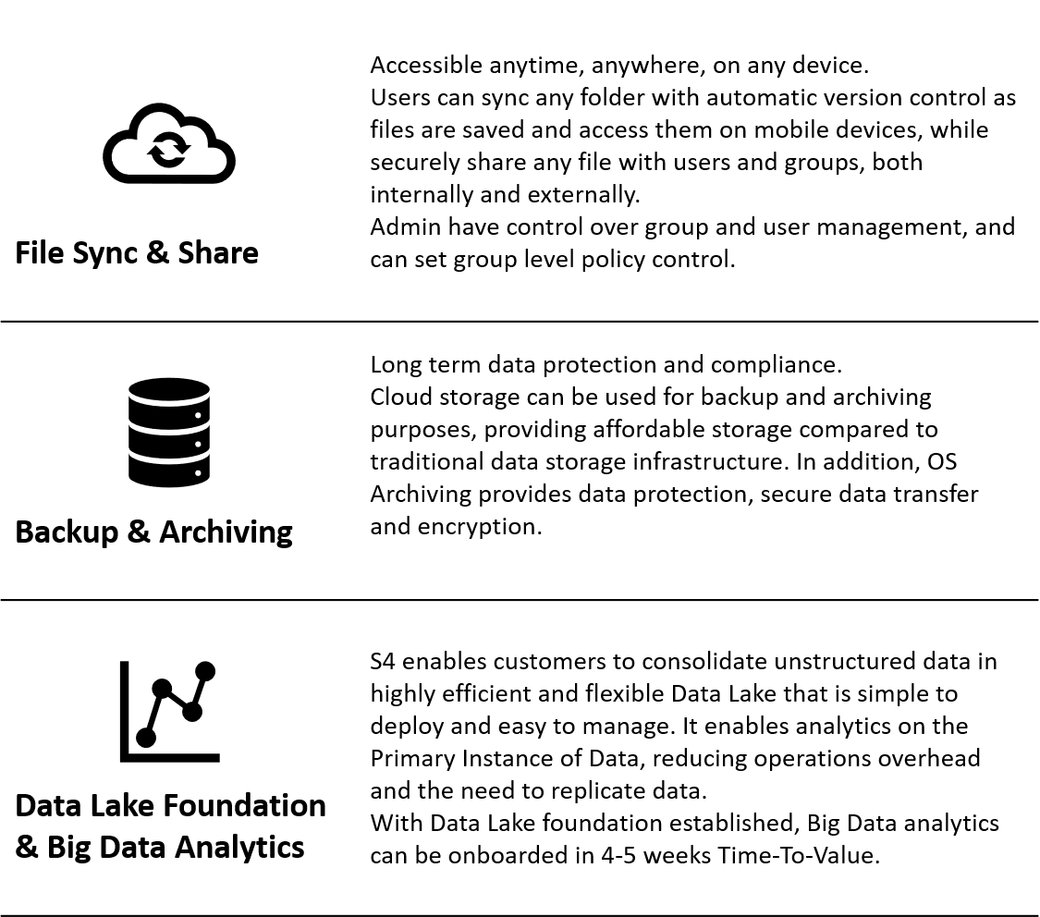

Discovery questions to ask your customer
- What type of data and applications does your business work with? Do you work with Big Data? Do you have a large amount of content such as photos or videos?
- Is dealing with vast amounts of data affecting your file shares? Does this data become inactive shortly after it is created but stays on primary storage for long periods of time?
- How do you currently backup your data?
- What is your position in terms of Disaster Recovery? Do you have a Business Continuity plan in place?
- Are you looking to move away from the complexity of managing storage platforms capacity, file systems or RAID groups?

Qualification questions to ask your customer
- Do you need to keep a lot of data online for compliance or other regulatory reasons or for its historical value?
- When you need to retrieve stored data, does it need high-speed access or would slower access be okay?
- Do you need your data to remain within the UK?
- What is your storage capacity and performance requirements?
- Would you like us to arrange a discovery call with our partner Expo-e to discuss the art of the possible for you when it comes to data storage and retrieval?

