Sales Enablement Pack
SD-WAN
Secure, smart and fast SD-WAN

SD-WAN - Sales Enablement Pack

Secure, smart and fast SD-WAN

Our SD-WAN solution is a virtualised, fully managed service to provide companies with the flexibility to utilise multiple access technologies. Overall enhancing the business agility and resilience required in today’s ever-changing world.

To achieve their business goals companies need an agile and resilient wide area network to securely connect any service, any application and any employee or partner regardless of location.

What is SD-WAN
- SD-WAN Provides a secure unified connectivity service over any transport technology, providing centralised management and operations, with full control and visibility of application performance.
- Based on the principles of SDN (software-defined networking), SD-WAN allows Network administrators to programmatically initialise, control, change and manage network behaviour dynamically. It’s essentially decoupling the infrastructure from the service using software-definition and network functions virtualisation (NFV).
- It is a service that gives enterprises the ability to seamlessly connect branch offices, data centres and cloud resources on a global scale.

Why SD-WAN
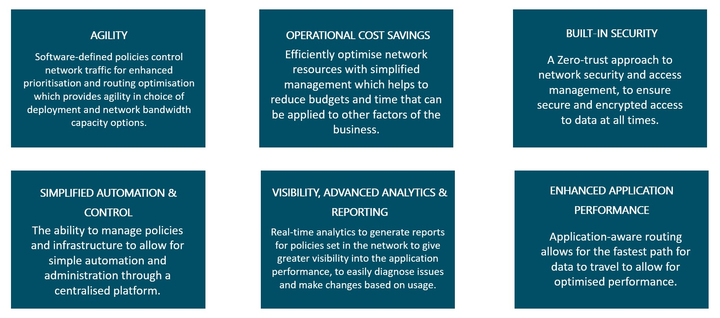

Market Information

By 2023 the SD-WAN Managed Services Forecast will be at $5,419M globally

By 2023, more than 90% of WAN edge infrastructure will be based on vCPE or SD-WAN software/appliances versus traditional routers (up from less than 40% today).

70% will adopt SD-WAN in the next 18 months (in some form)

50% of SD-WAN deployments are managed by a Service Provider

Why Expo-e for SD-WAN
- Expo-e’s SD-WAN is the result of more than 17 years of experience working with Nokia (Nuage Networks), innovating and providing high-performance WAN solutions to our partners and your customers with the most modern SDN technologies available.
- When partnering with Expo-e, your customers can leverage this expertise to design and optimise high-performance networks. We guide you and your customers on a journey from initial design and deployment, through to ongoing refinement of configuration and policies to best meet their evolving requirements.
- You and your customers will benefit from our 24x7x365 Service Desk and through the SD-WAN portal you and/or your customers have access to their entire network information via an online portal to monitor, analyse, and revise their network.
- We manage and support the SD-WAN solution end-to-end
  - Design, integrate, troubleshoot, upgrade, logistics, etc.
  - Infrastructure (compute, HV, networking, security, etc.), OSS/BSS system integration (provisioning, monitoring, etc.), branch connectivity (multiple underlays, etc.), Public cloud.

Features & Benefits
- Application Awareness – Measure path performance and dynamically steer applications to meet service level expectations using a library of 1400+ application signatures and custom configuration.
- Any Network Transport – Global Reach - Bring together private and 3rd party MPLS networks globally, DSL, and 4G connected sites under a single policy-controlled service. By using a combination of low-cost internet access with high capacity MPLS circuits your customers can save money by off-loading non-mission-critical applications from the network.
- Security - Policy-based Encryption of data and stateful awareness of traffic flow is essential in today’s world of cyber security. Help protect your customer’s reputation in the global market.
- Cloud integration - Expo-e provides automation of the cloud since 2014, now we have extended this policy-based control to provide seamless integration with the WAN as well as extending reach with the deployment of virtualised network appliances in AWS and Azure Cloud platforms.
- Software-Defined Policies – Routing Network traffic with enhanced prioritisation and routing optimisation to give your customer an agile choice of deployment with many network bandwidth capacity options.
- Cost Efficiencies - Achieve more – optimize available resources, reduce spend on engineering and put the focus on delivering application performance.
- Performance Reporting - Real-time performance monitoring of transport networks to make application-aware, policy-based network selections which reduce reliance on MPLS-only based links. The portal provides full application performance visibility enabling your customers to build a comprehensive strategy addressing today’s needs and planning for future growth and services.
- Central Management - Deploying changes on the SD-WAN platform is straightforward and done through a portal. It’s simply a matter of changing centralised policies. This avoids traditional network engineering complexity, allowing for automation and simple administration to increase control and ease of network management.
- Zero-touch - provisioning of devices that do not require local IT staff presence which improves speed-to-market through faster deployment of branch sites, enabling enterprises to react quickly to changing market conditions. No pre-staging required as the appropriate policy is automatically downloaded along with any software updates needed.
- SD-WAN Overlay - We can overlay our SD-WAN services regardless of your customers’ existing network supplier which allows for a seamless and secure transition.

Product Matrix
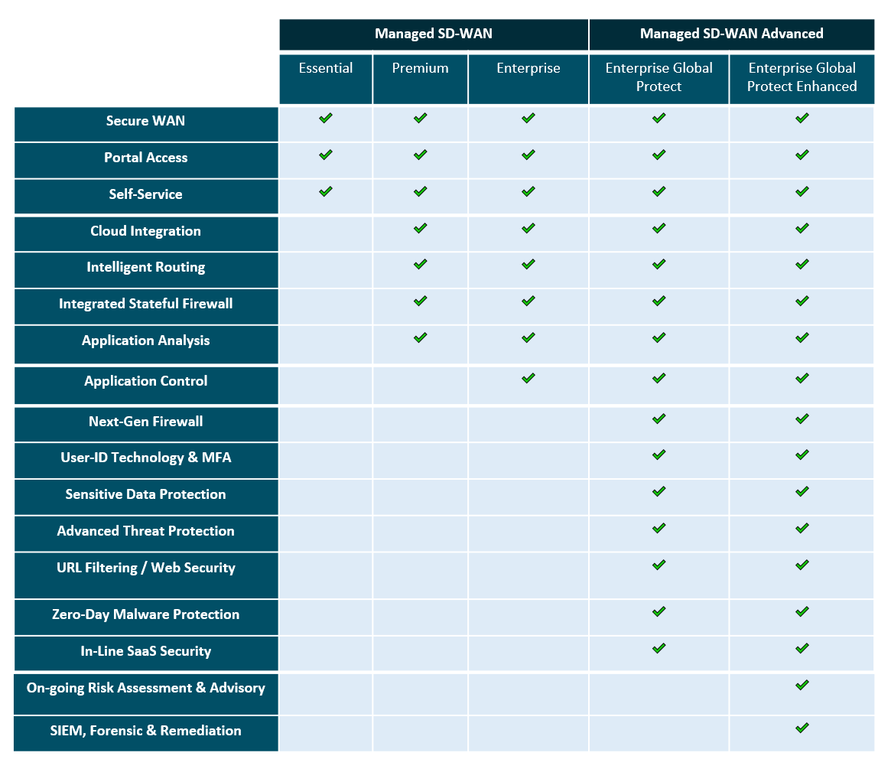

Enterprise Global Protect
- Next-Generation Firewall – Prevention focused architecture and integrated innovations such as Threat Prevention, WildFire Malware Analysis, URL Filtering and DNS Security to protect your customers against modern security threats like credential theft and data exfiltration.
- User Technology and MFA - An added layer of security used to verify an end user's identity when they sign into an application.
- Sensitive Data Protection – Protection of sensitive data within the business to apply to GDPR.
- Advanced Threat Protection - Protection is powered by continuously growing threat intelligence from tens of thousands of global customers collectively sharing trillions of artefacts to prevent unknown attacks.
- URL Filtering/ Web Security - URL Filtering enables you to safely use the web for business needs. Go beyond basic web filtering by identifying threats with automated protection through a unique combination of static analysis augmented by machine learning.
- Zero-Day Malware Protection – Protection against malware that is yet to be known.
- In-line SaaS Security – Compliant with SaaS Security policies as set by the National Cyber Security Centre.

Enterprise Global Protect Enhanced

On-going Risk Assessment and Advisory – CSOC services to provide advice on what security risks may lie within the business and how they can remediate these risks. SIEM, Forensic & Remediation – Providing a solution to combat any security risks within the business.

Eco-Friendly SD-WAN
Through the use of cloud services, the ability to share resources via multi-tenancy options optimizes the use of connectivity and bandwidth efficiency. This can also mean that fewer branch devices are deployed, which overall reduces resources used for power and cooling, overall reducing a businesses’ carbon footprint.

Video
https://sway.office.com/6OJHPsQcAnC45P2f#content=WyjY1FWQ6y75ge
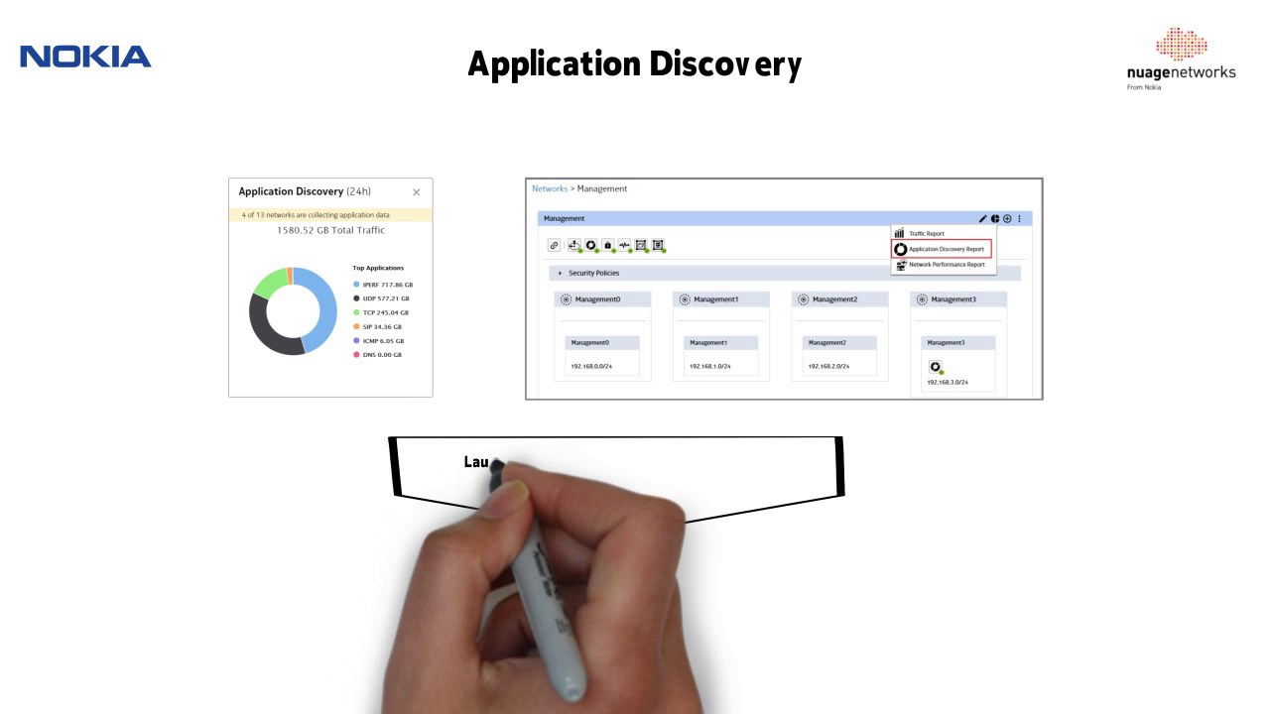

Discovery questions to ask your customer

What is the motivation for pursuing SD-WAN? Features that you believe would be beneficial?

Do you need to address connectivity for regional or global deployments?

Do you need to address connectivity requirements for on-premises or cloud/SaaS applications?

Do you want to manage your WAN in-house or have it delivered as a service?

Are there certain features that you would like to see when looking at monitoring and analytics in the portal?
- Are there certain applications for which you would like to establish service level agreements/traffic steering / SLA thresholds?

Qualification questions to ask your customer

Application & Cloud
- Which applications are mission-critical to the business?
- Where are these applications hosted?
- How do users access critical applications? Locally / remotely / any policies in place?
- Are you able to provide application dependency mapping of your critical applications?
- Can you tell me about your cloud connectivity? Are you adopting more cloud-based applications and services (SaaS, IaaS).
- How is performance and reliability for SaaS and public cloud services traffic assured?

Security
- How is your current WAN solution architected for security?
- What is the existing firewall vendor/product? Who manages the firewalls?
- What other security layers do you have on your current network?
- What are your key security requirements at the Datacentre level?
- What are your key security requirements at the Site level?
- Next Generation Unified Threat Management Requirements?

Routing
- How resilient is your current WAN solution? Is it architected for high availability?
- Does the current solution offer dynamic support of multiple active links?
- How do you breakout to the Internet? (Centralised / Site level).
- Load balancing / WAN Optimisation requirements?
- IP SLA requirements to measure Jitter / Packet Loss / Latency?
- Do have Interior Gateway Protocol (IGP) running on your LAN side of the network?
- Does the current solution have QoS running across your WAN?

Current Network
- What is your current WAN Topology / Number of sites? (Datacentres / Branch Sites).
- Do you currently profile your sites (Large / Medium / Small)?
- What is your current WAN hardware / vendors?
- What is your current WAN Services / traffic segregation? (e.g Data / Voice / Guest Wi-Fi)
- What are your current bandwidths requirements?
- Do you currently monitor your network? If so, what Monitoring tools do you use?

