Our Portfolio - Cloud
Cloud without the fog

Solutionize with EXPO.e

As part of the EXPO.e Channel community, we can help elevate your business by combining our expertise, experience, and evolving portfolio with your own, opening the door to new service innovations and margin-rich new revenue streams.

Why EXPO.e
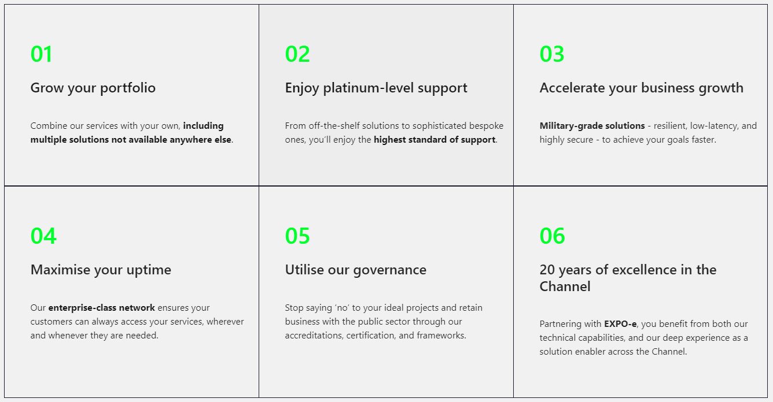
We’re a UK pioneer in Cloud, Connectivity, Unified Communications, and Cyber Security, with more than twenty years’ experience enabling other organisations to grow, innovate, and drive positive change. Here’s what we can do for you.

Collaboration, consultation and community
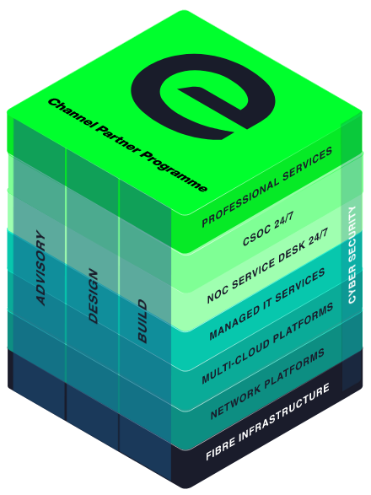
We cultivate partnerships built on collaboration and consultation, that empower our Channel community to bring tomorrow’s innovations to life today, even for contracts they’d have previously been unable to fulfil.
Whatever the size of your organisation, the sector you operate in, and your ideal customers, we are here to help you achieve your full potential - not only bringing your products and solutions to market, but helping you transform interested prospects into longstanding, repeat customers.

We own our network so you can guarantee value to your customers
Our Layer 2 VPLS, high capacity, business-only Network offers seamless interoperability, right into the Cloud infrastructure - an enterprise-class Cloud Network model that sets us apart.
EXPO.e as your partner for Cloud services will make the difference for both your customers and your business.
.
Our Cloud Toolbox is your Toolbox
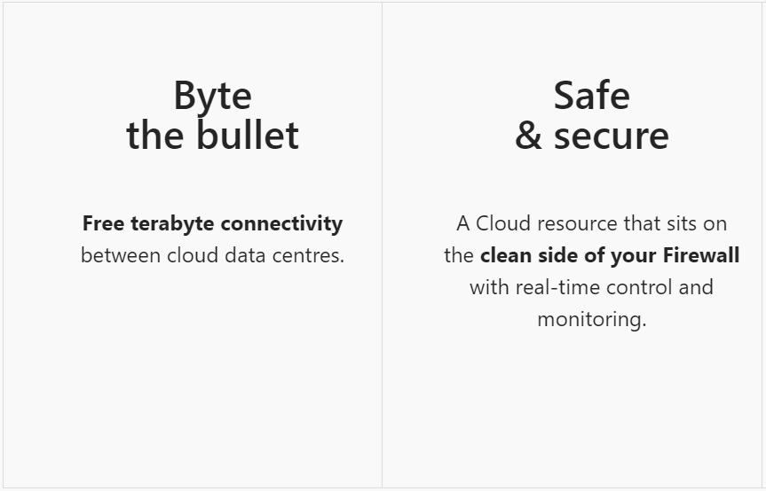
Cloud Services
Cloud Storage
- S4, Enterprise File Services
- Ultra low-cost Object Store
- Storage-as-a-Service
Disaster Recovery / Data Protection
- Service Replication (RPO 15 mins RTO as low as 30 mins for specific VMs)
- Online Backup & archive with long term retention
Hosting Services
- Colocation, Hyperconverged Private Cloud and Virtual DC
- VOI apps / Desktops utilising Citrix VDI GPU options for hyperscale compute
- Cloud Management Platform
Public Cloud
- AWS, Microsoft 365, Azure
Virtual Workspace
- Citrix-as-a-Service, Citrix Management Desktop

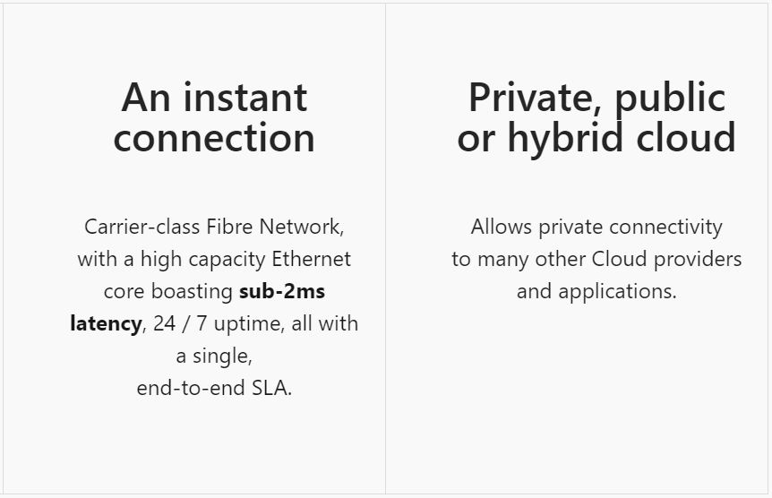
Our resources are your resources
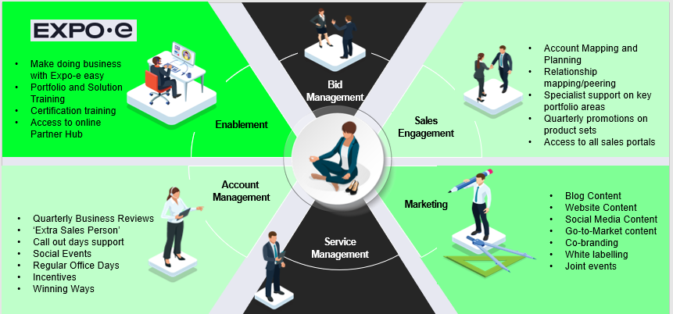

Exceptional service quality is part of our DNA
Exceptional service quality is part of our DNA and has been for more than twenty years. That’s why we display our industry-leading Net Promoter Score (NPS) live on our website.
We don’t do tiers of service. Whether you are a Carrier, Reseller, or Referral partner, you are automatically a Platinum Partner.
Deliver
- Direct dial contacts to our provisioning coordinators with escalation points up to our Director of Service Delivery
- Weekly order trackers / provisioning calls
- Coming soon – live Partner dashboards
- Executive level relationships with all last mile providers

Enable
- Make it easy to do business with EXPO.e
- Deliver a consistent strategy enabling you and your teams to grow pipeline and win new business
- Listen to you and understand what we need to do to make your teams successful

Margin
- Move from 10% to 40% margins by expanding your solution offering and adding more value
- Maximise profits by delivering better business outcomes for your customers
- Increase retention by helping customers overcome more challenges

Support
- Fault, Find & Fix 24x7x365 UK support with 1st, 2nd & 3rd line engineers
- 24x7 Proactive monitoring, reporting back to you about customer service outages
- ITIL trained and ISO20000 compliant so you can be rest assured that you and your customers are in safe hands

This is what good looks like
