Partner Self Service Guide
Unified Communications and Contact Centre
Table of Contents
Introduction 3
Step-by-step Onboarding Process 3
URL’s for Portal’s 3
Partner Self Service Configuration 4
Creating Customer Groups 4
Adding Numbers 6
Setting the business Profile Number 8
Setting up your Voice Portal 9
Admin Users 11
Akixi Configuration 12
Akixi Admin Users 14
Call Cabinet Configuration 18
Porting 21
High Level Porting Overview 21
Information Required (UK) 21
How Long Does It Take? 21
Risks 21
Contacts 22
Escalation Matrix 22

Introduction
This document highlights the steps to being onboarded as an EXPO.e reseller partner of Unified Communications and Contact Centre. This guide will show you the best practices for creation of your customers and the process flow for service builds.

Step-by-step Onboarding Process
1 - UC Provisioning administrator will send across order confirmation within 48 hours of the signed on-boarding order being received.
2 – A UC Provisioning Co-Ordinator will be assigned to create the required Partner accounts in the relevant systems, ready for creation of end customers.
4 – The UC Provisioning Co-Ordinator will then be in contact to arrange for a kickoff call and provide an introduction to the allocated trainer.
5 – Training will then be provided on the required platforms.
6 – The platform access will be made live, and the partner can start creating customers and users via the self-service portals.

URL’s for Portal’s
There are two branded URL’s available for the EXPO.e portal, one for end customers, providing the ability to manage existing features and services at both a site / customer and user level and one for Partner self-service provisioning, proving full admin read and write access for the reseller partition. Please ensure you share only the correct URL information with your customer.
End Customer Portal: https://ucaas.hostedcomm.com/app/#!/
Partner Portal: https://ucaasprov.hostedcomm.com/app/#!/

Partner Self Service Configuration

Creating Customer Groups
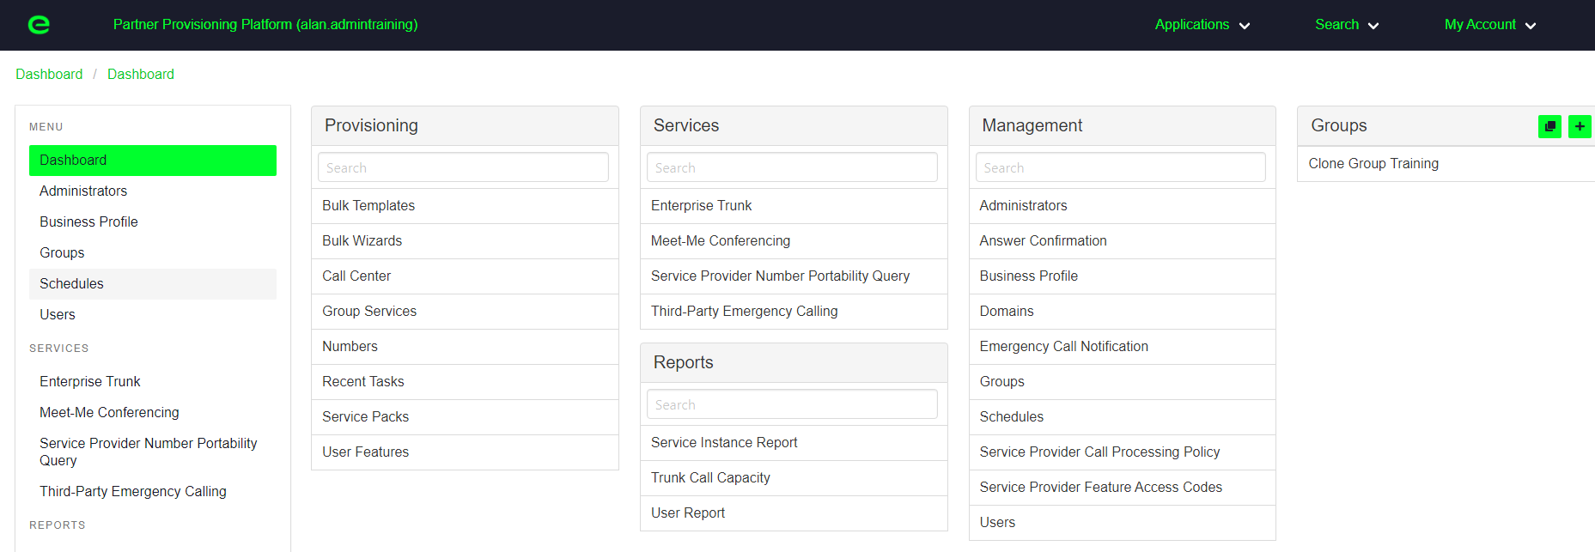
Prior to handing over an order to a Partner a UC Provisioning Co-Ordinator will be assigned to create the partner access required to allow resellers to build customers and users.

Access to the Partner Self-Service Portal will be provided, and a Clone Group will be created (as above) which will have the required settings pre-set to allow the creation of end customers / users.
Once ready to create a customer, first click onto the clone group icon as above.
This will bring up the below settings where the Clone Group can be selected, which has already been pre-built into the reseller account.

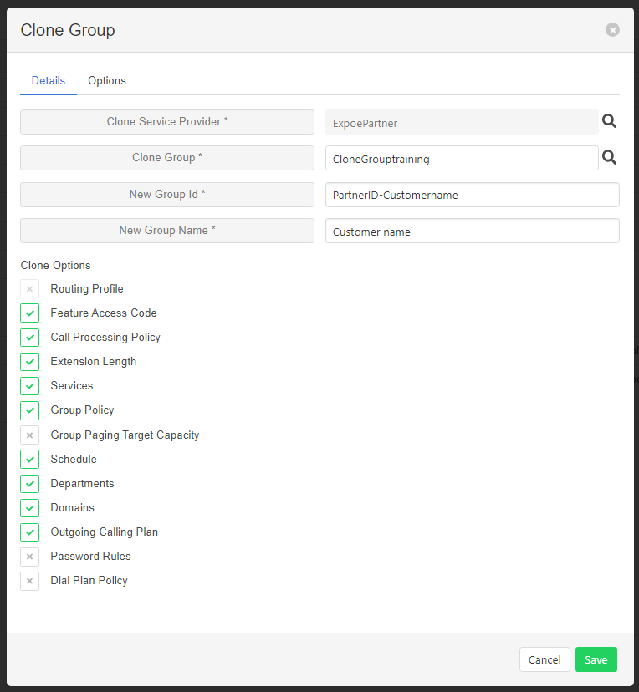

All of the below settings must be completed in-order to build a customer. Please see below recommended build structure.
Clone service provider: This will be pre-set as ExpoePartner.
Clone Group: Click into the group and select the “Clone Group” labelled, which has been purposely created for the reseller account.
New Group ID: The group ID must be unique in the platform. It is recommended that the Partner ID is set as the end customer’s name.
New Group Name: This field doesn’t need to be unique and should be set as the end customer’s name.
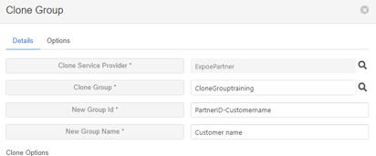

Next click onto the options tab, from here the default domain must be set for the customer, this can either be Exponential-e.com or Hostedcomm.com depending on your preference for the customer. This will be used against all user IDs within the company.
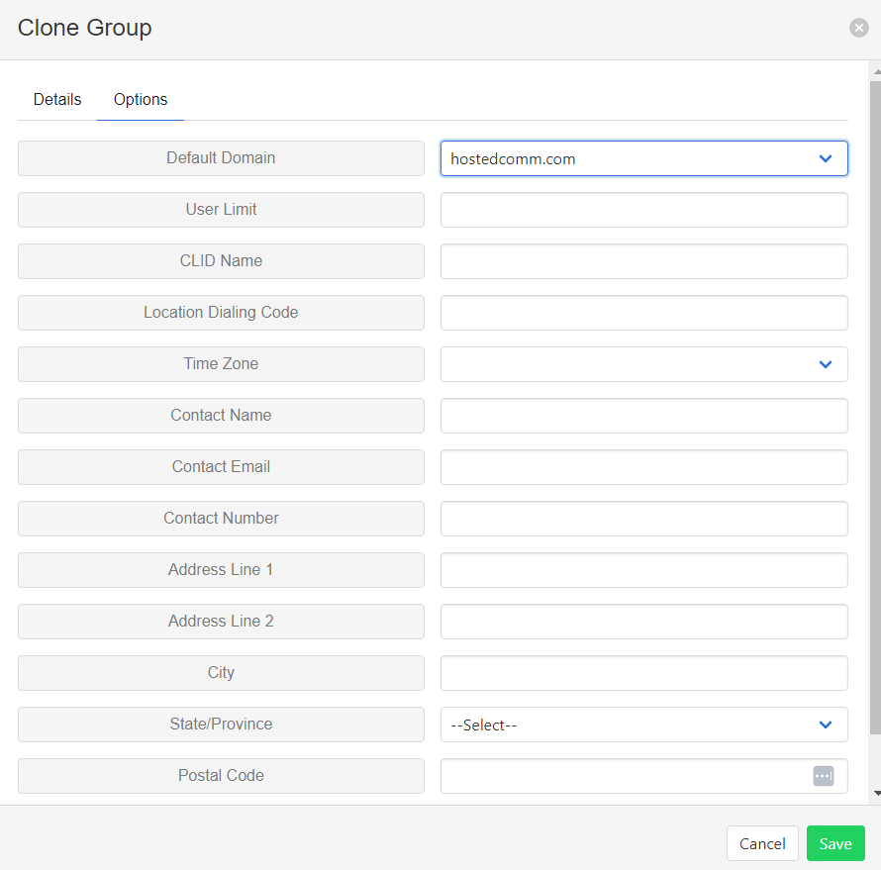

Once selected, press save. The group has now been created and this is now under the reseller account.
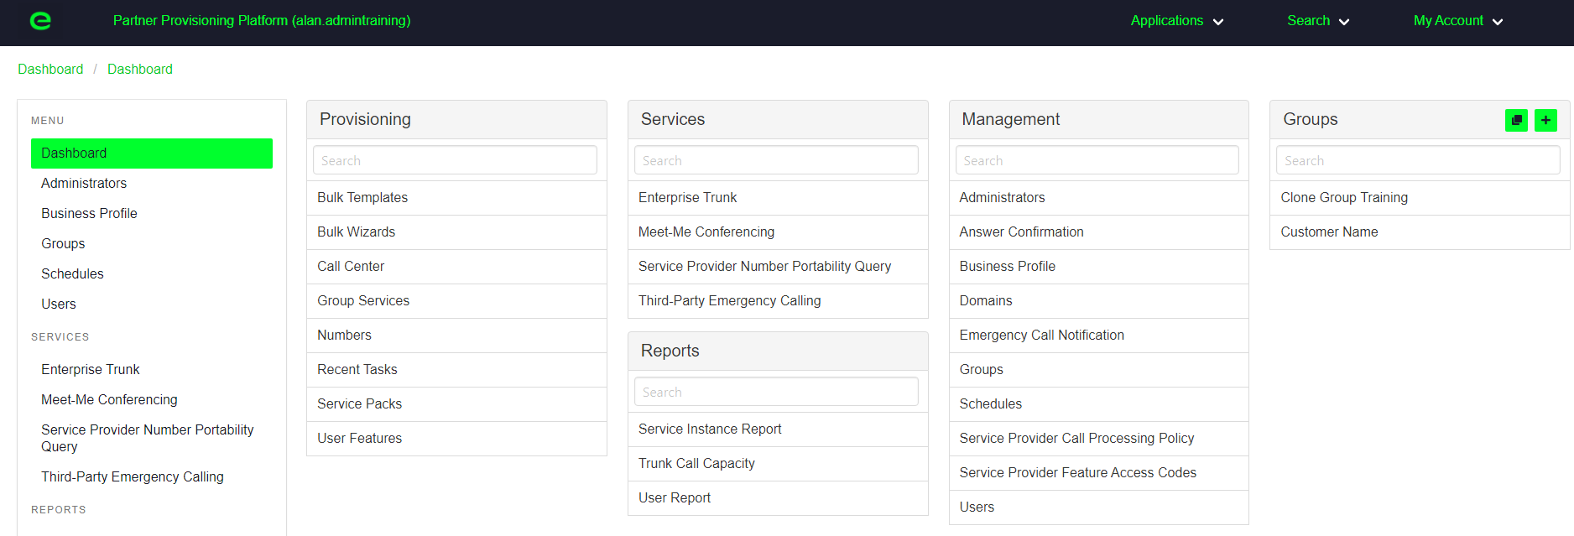
The below 4 settings now need to be configured to ensure the groups is ready for users to be built.
- Adding Numbers onto your Partner account and customer account
- Setting the business profile number
- Setting up your voice portal mailbox (to allow voicemail on users)
- Creating admin users

Adding Numbers
When adding new numbers, or numbers which are being ported the first step will be for the Expo-e Voice Provisioning team to add these onto your Partner account ready for you to assign out to your customer.
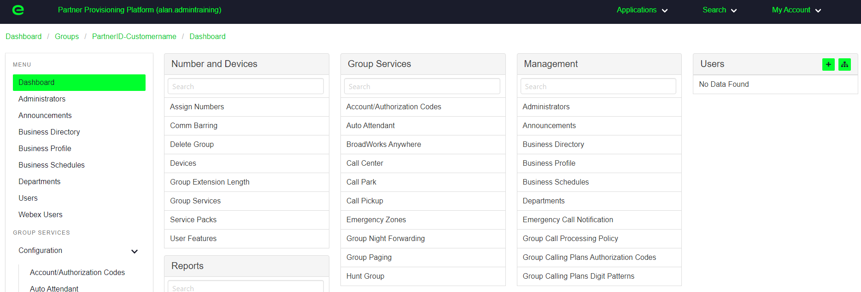
Once these are on your Partner account you will be able to select your customer group and then select assign numbers.

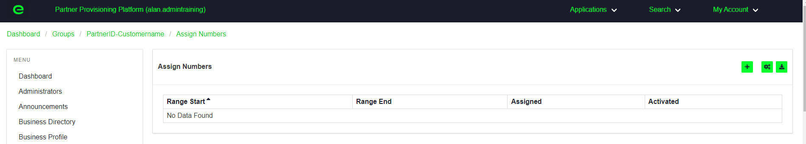
Then click onto the + button to assign numbers from your Partner account to the selected customer.

This will display all numbers you have available within your Partner account. Select the numbers required and press save. These will now be available for selection within your customer group.

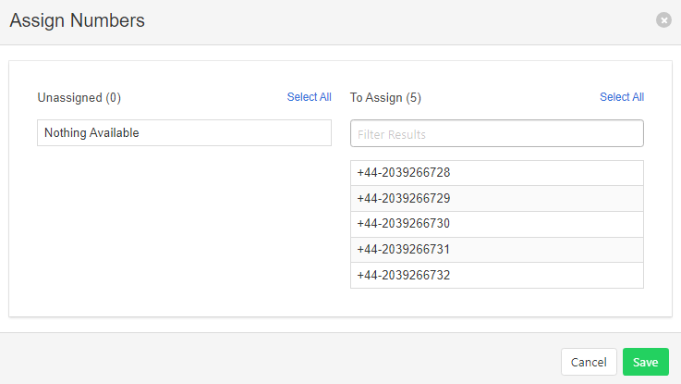

Setting the business Profile Number
For all groups a business profile number must be selected. This number will allow extension dialing calls from within the organization to route across to users. This number can also be set as a group number to dial out from should the organization require this.
Under management select business profile.

Once selected click on the settings and it will take you into the below, select the optional tab and then click into the CLID number. In here you will see all numbers available within your group and you can select the number required (you can select any number, if users will present their own CLID as this will not change that).

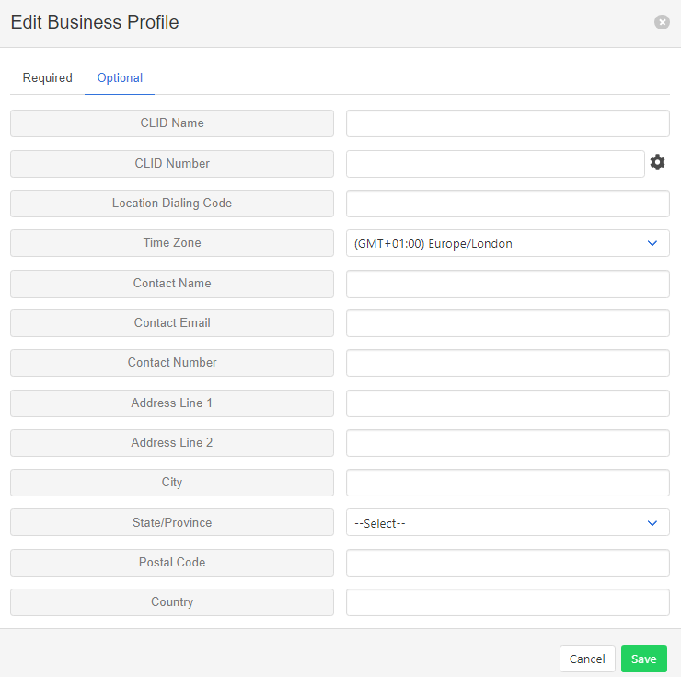

Setting up your Voice Portal
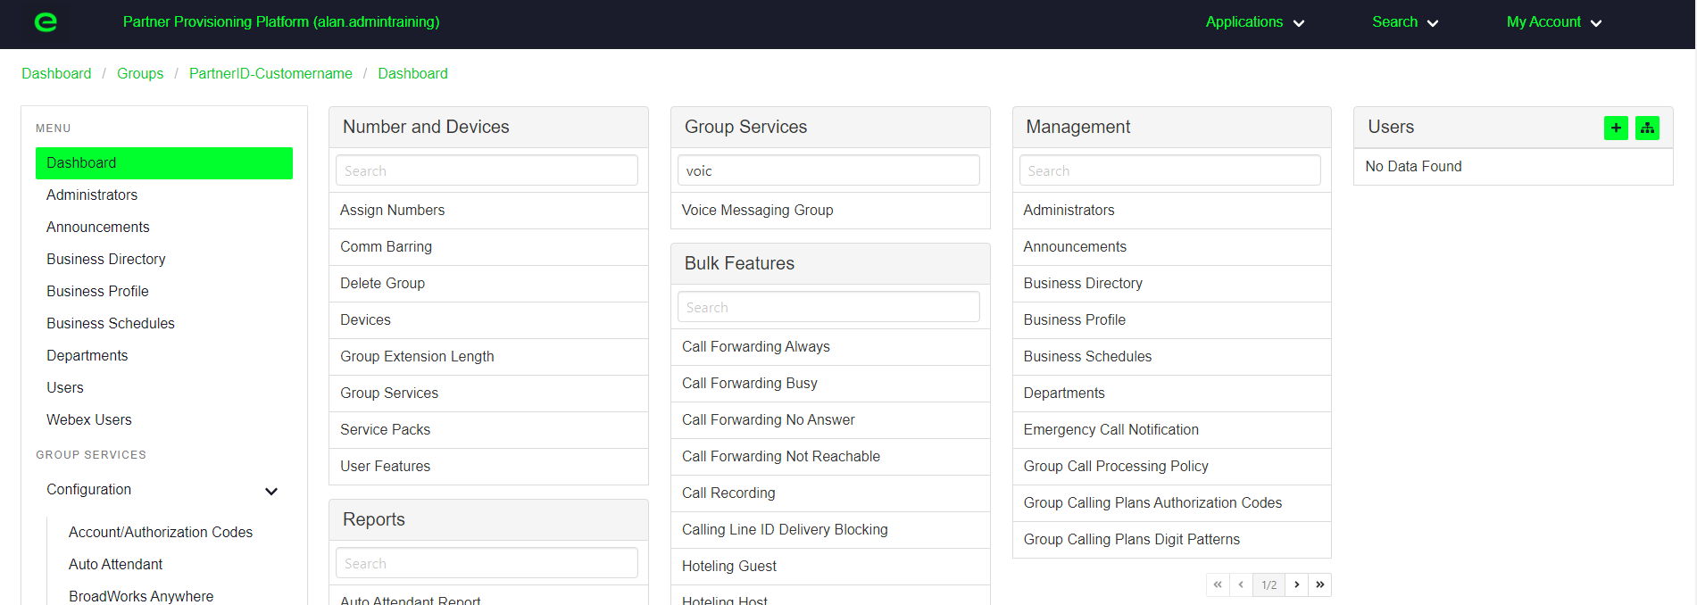
In order for the customer to have voicemail activated the voice portal must first be set up with a number or an extension to allow for voice messaged to be stored. To set this first search under group services for voice messaging group and select this.

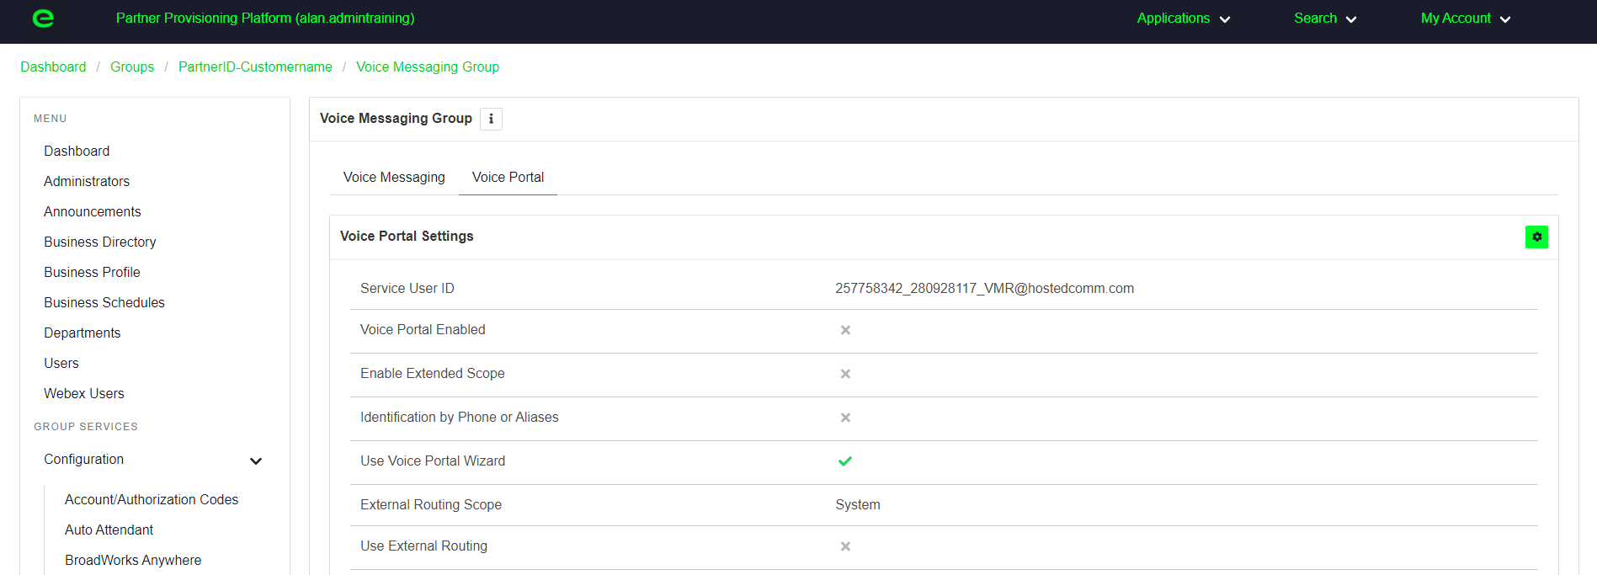
Within the voice messaging group, select voice portal tab and click on the settings cog.

Within the settings tick the top box, enable voice portal and select save.

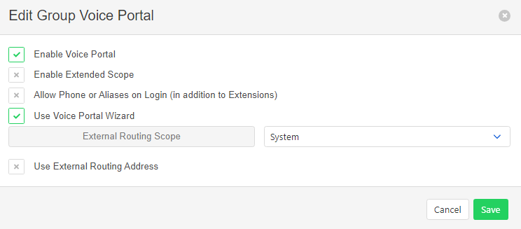

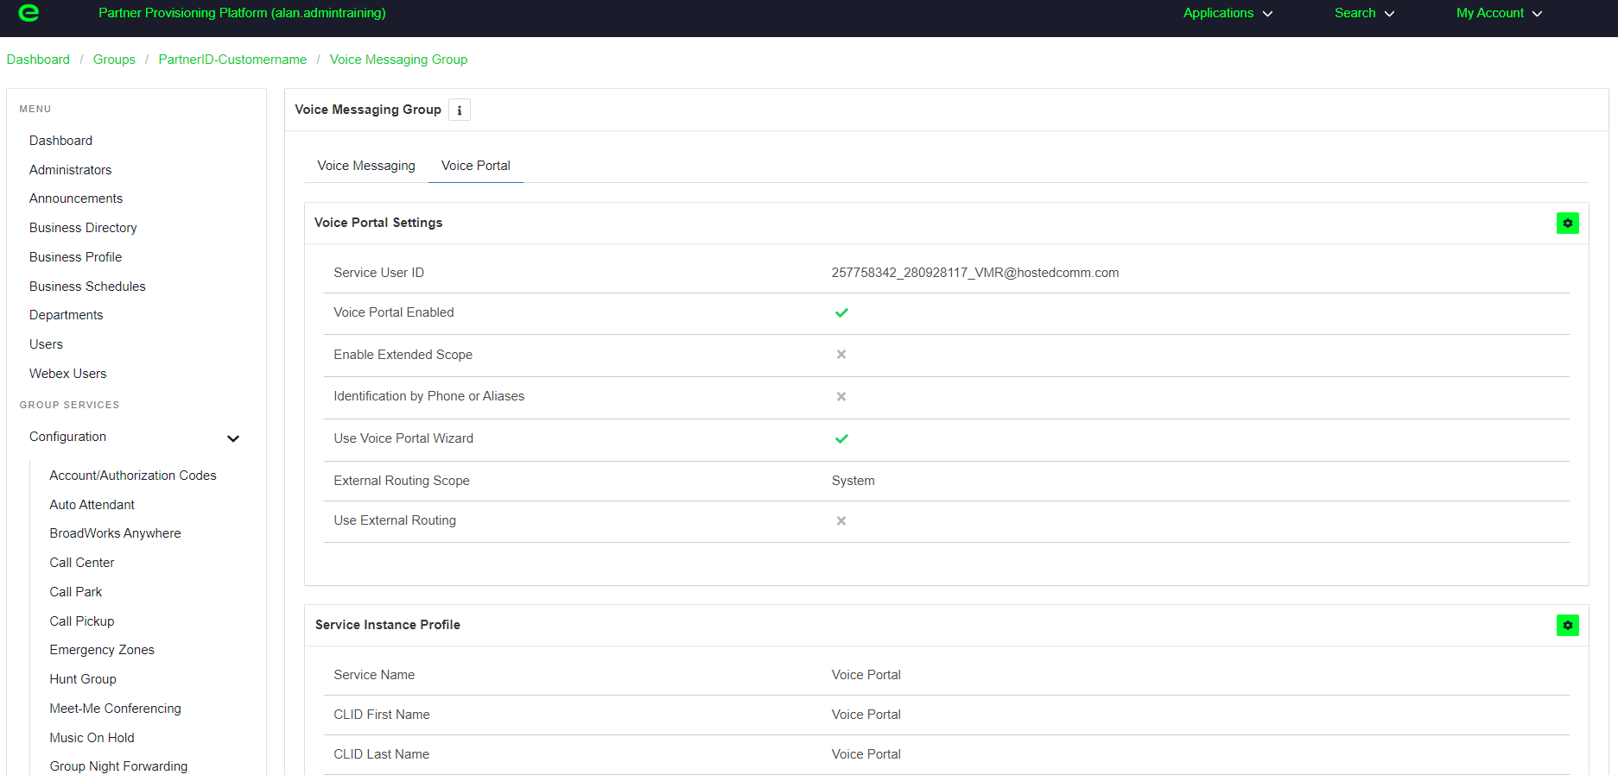
The Service Instance Profile will then be added onto the options. Click on the settings cog below.

Next either add a phone number or an extension into the below box and save your changes. If the customer requires the ability to dial into their voicemail from a personal number such as a mobile phone, a number must be selected, rather than just an extension.

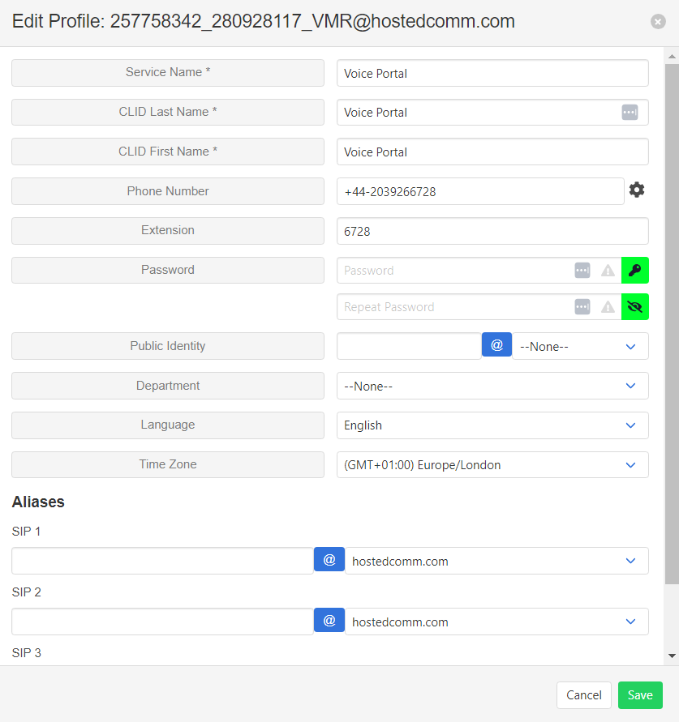

Admin Users
To create customer admin accounts please click on administrators under the management section.

Click on the + to add a new administrator. The user ID must be unique. If the name will not save it is likely that the user ID is not unique. First name, dot, surname will usually be accepted. Please then also complete the first and last name and either type a password or you can click onto the key to generate a password. To view the password, click on the eye and you will see a preview. Once completed select save.
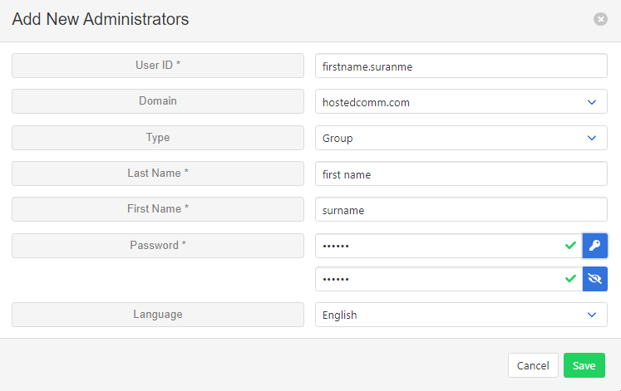
The user ID will then be saved in the format firstname.surname@hostedcomm.com (please note the user ID is case sensitive).

Akixi Configuration

Prior to handover, EXPO.e will also build an Akixi reseller account within Akixi. This will allow partners to go in and create new customers, ready for Akixi reporting. Once created you will receive a welcome email from Akixi with your login information.

Login to Akixi with the credentials provided.

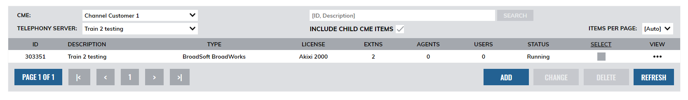
To create a customer (partition), first click onto the add button shown below.

This will bring up the window to add a new partition. The below information needs to be completed.
Description: End customer name
Billing ID or Tag: This will be the customer ID you have set within the Partner Self-Service Portal for this customer.
Licensed for: Select the licence required for your customer, note this will affect their billing.
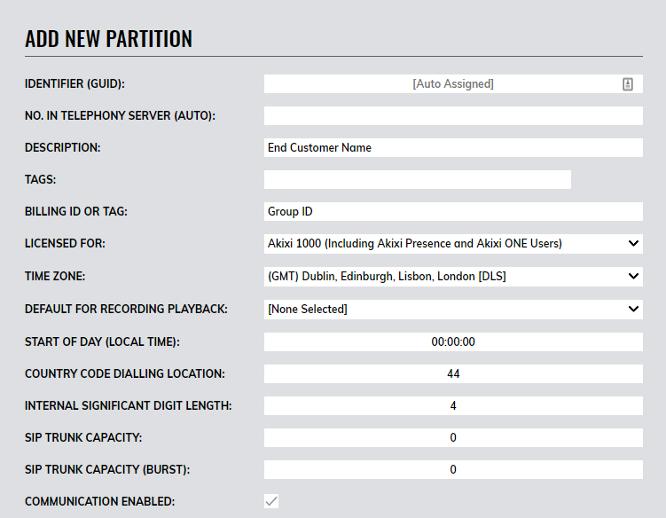

Type on telephony server – Select “Service Provider Group”
Enterprise or Provider ID - Partner ID (set by Expo-e in Partner Self-Service Portal)
Group ID – End customer group (set by Partner in Partner Self-Service Portal)
Synchronisation Type – This must be set to “By Service Pack”
Maintain Parity – Please ensure that this box is ticked. This will ensure your groups are synced every night.
Perform Synchronisation now – Tick this box if you need to sync the license without waiting for the auto sync that evening. This would likely be used once you have assigned licenses out or removed licenses within the Partner Self-Service Portal. You can complete the sync to see that the licence count has been updated.
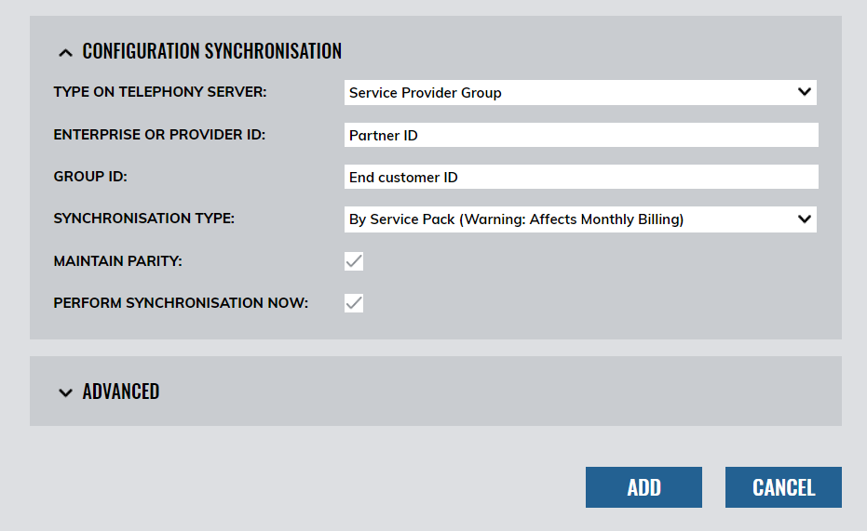
Once completed, select add to save the customer configuration.
This will now show on the Akixi page under the reseller account and the status should be shown as syncronisation completed. If it is not showing as completed, click the sync button to update.
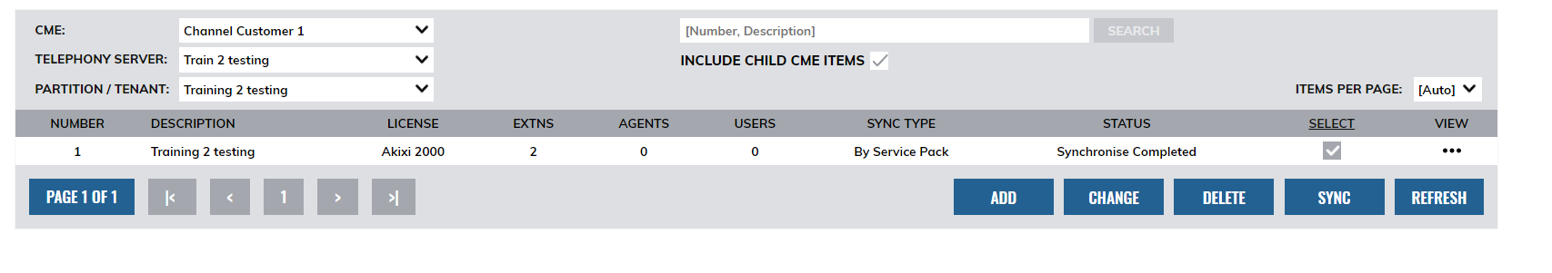

Akixi Admin Users
Admin users will need to be setup for the customer to be able to log into Akixi and run their reports. To set a new user up, select users under the view section of the customer account as below.

This will open the add application user account window which will need to be configured. For the User Details tab please configure the settings as below to set up the admin user, including a unique username.
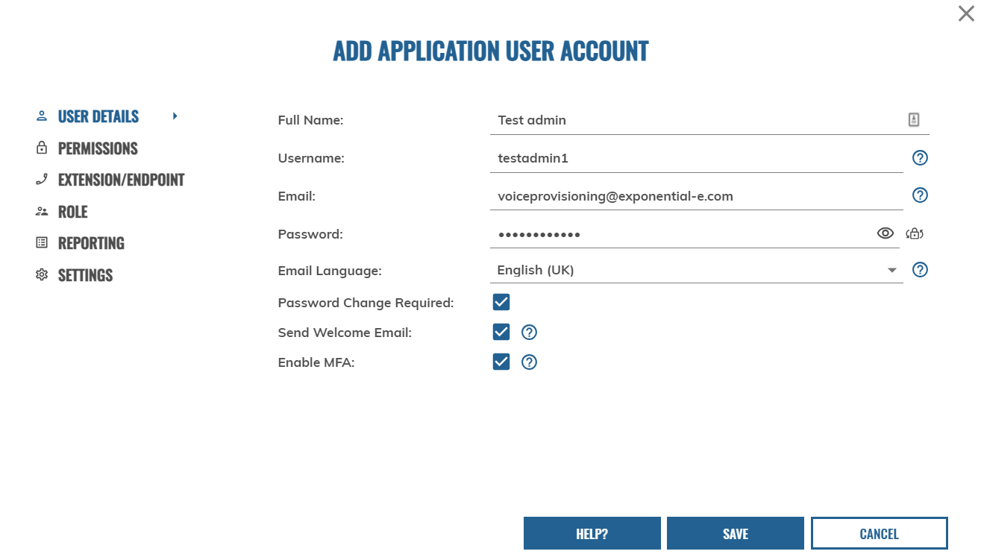
It is recommended to select “Password Change Required” and” Send Welcome Email” This will provide the admin user with access and URL as required. It is also recommended to select “Enable MFA”.

Within the Permissions tab the customer (Telephony Server) can be selected from a drop-down menu of the customers that have been created.
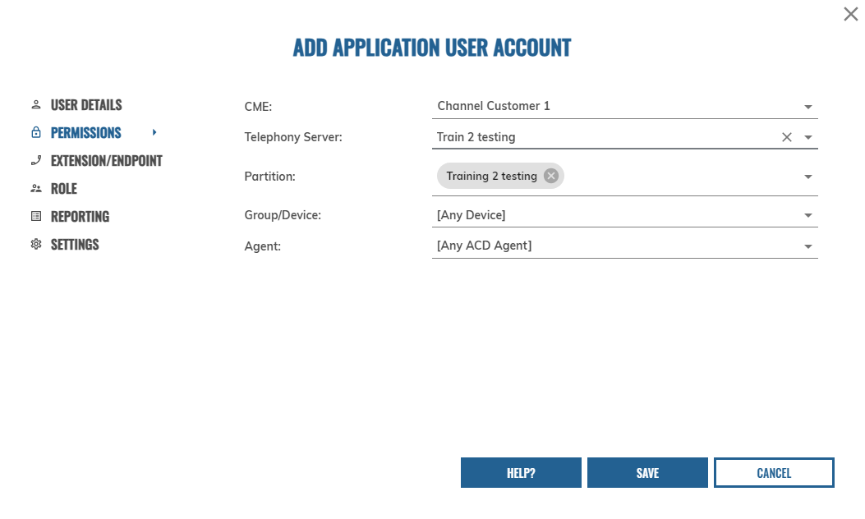
The partition must be selected to allow the customer to have access to their own reporting only. If “Any Partition” is selected this will allow access to all customers so should only be selected for Partner access. Group/device and agent can be left as any, unless the customer would like to restrict the admin user to only report on selected users.
Within the Extension/Endpoint tab please leave blank/not ticked unless restricting the user to only certain devices to report on whereby you can select as needed.
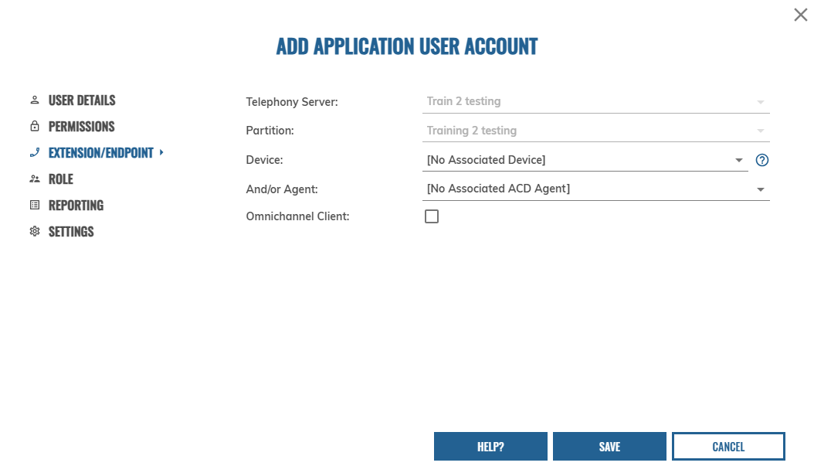
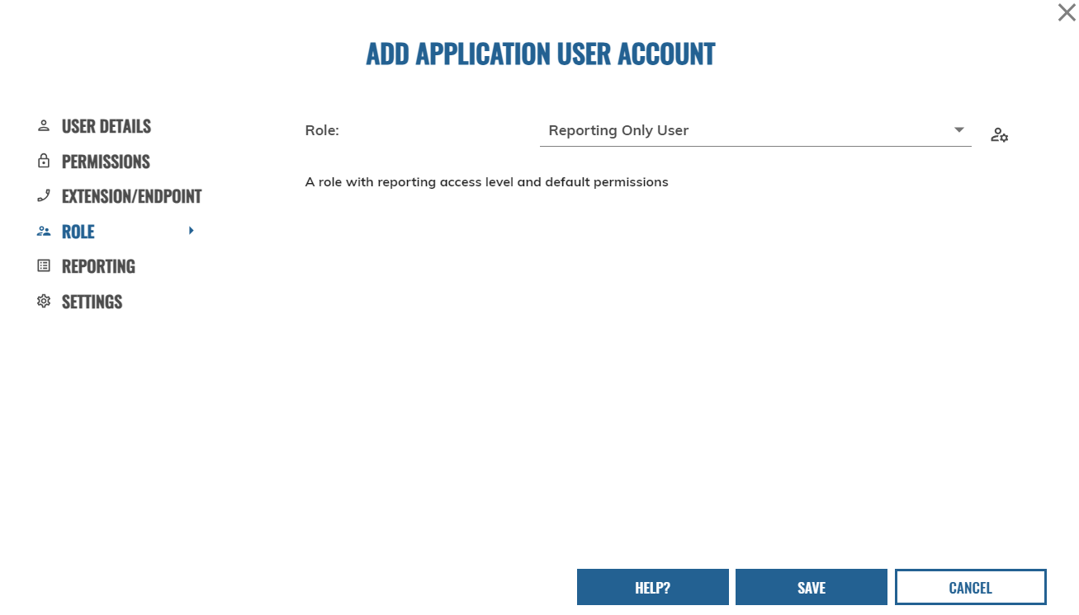
Under the Role tab select “Reporting Only User”

For the reporting tab select “1000 Supervisor” for the reporting level and “Standard Reports” for the default reports (this will provide pre-built reports ready for your customer once logged in).
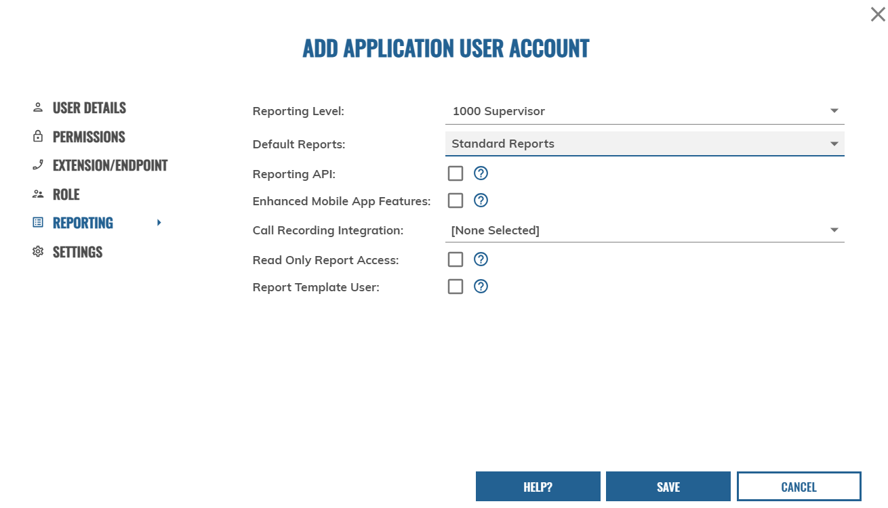

The settings tab can be set as the default view below. Once all tabs have been completed, click the save button.
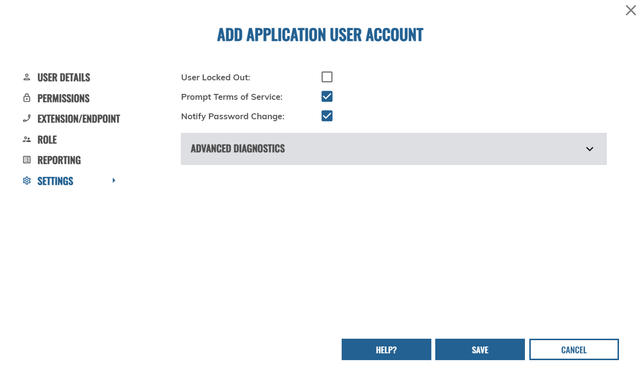

The user will now appear as below under the customer account.
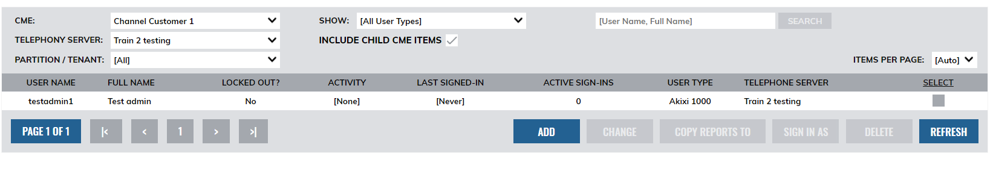

Call Cabinet Configuration

Prior to handover, EXPO.e will create a Call Cabinet reseller account. This will allow partners to build new customers, ready for call recording. Once the reseller account has been created the partner will receive a welcome email from Call Cabinet providing login information.
Login to Call Cabinet with the credentials provided.
To set up a customer for call recording, first click onto the “Add New Essential Customer” button as shown below. (Please ensure you do not select “Add New Customer” as this will set up the customer incorrectly and affect billing)
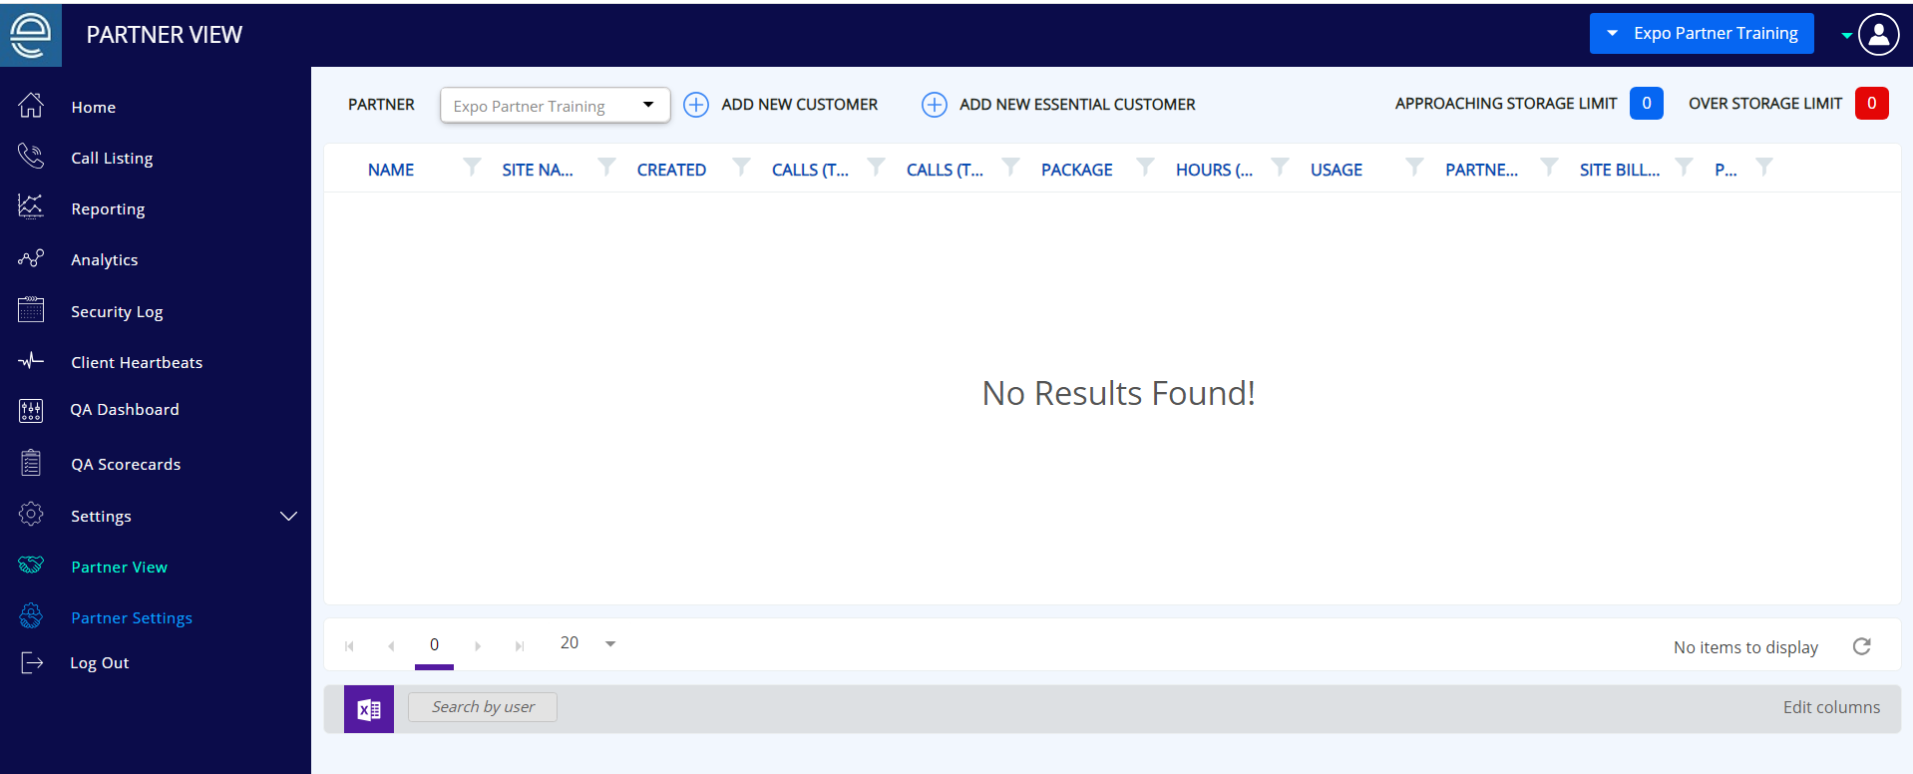

Once selected the company details will need to be completed as below. For the internal Dealer Code and Billing Code please add the Customer reference number or Customer name that has been created within the Partner Self Service Portal.
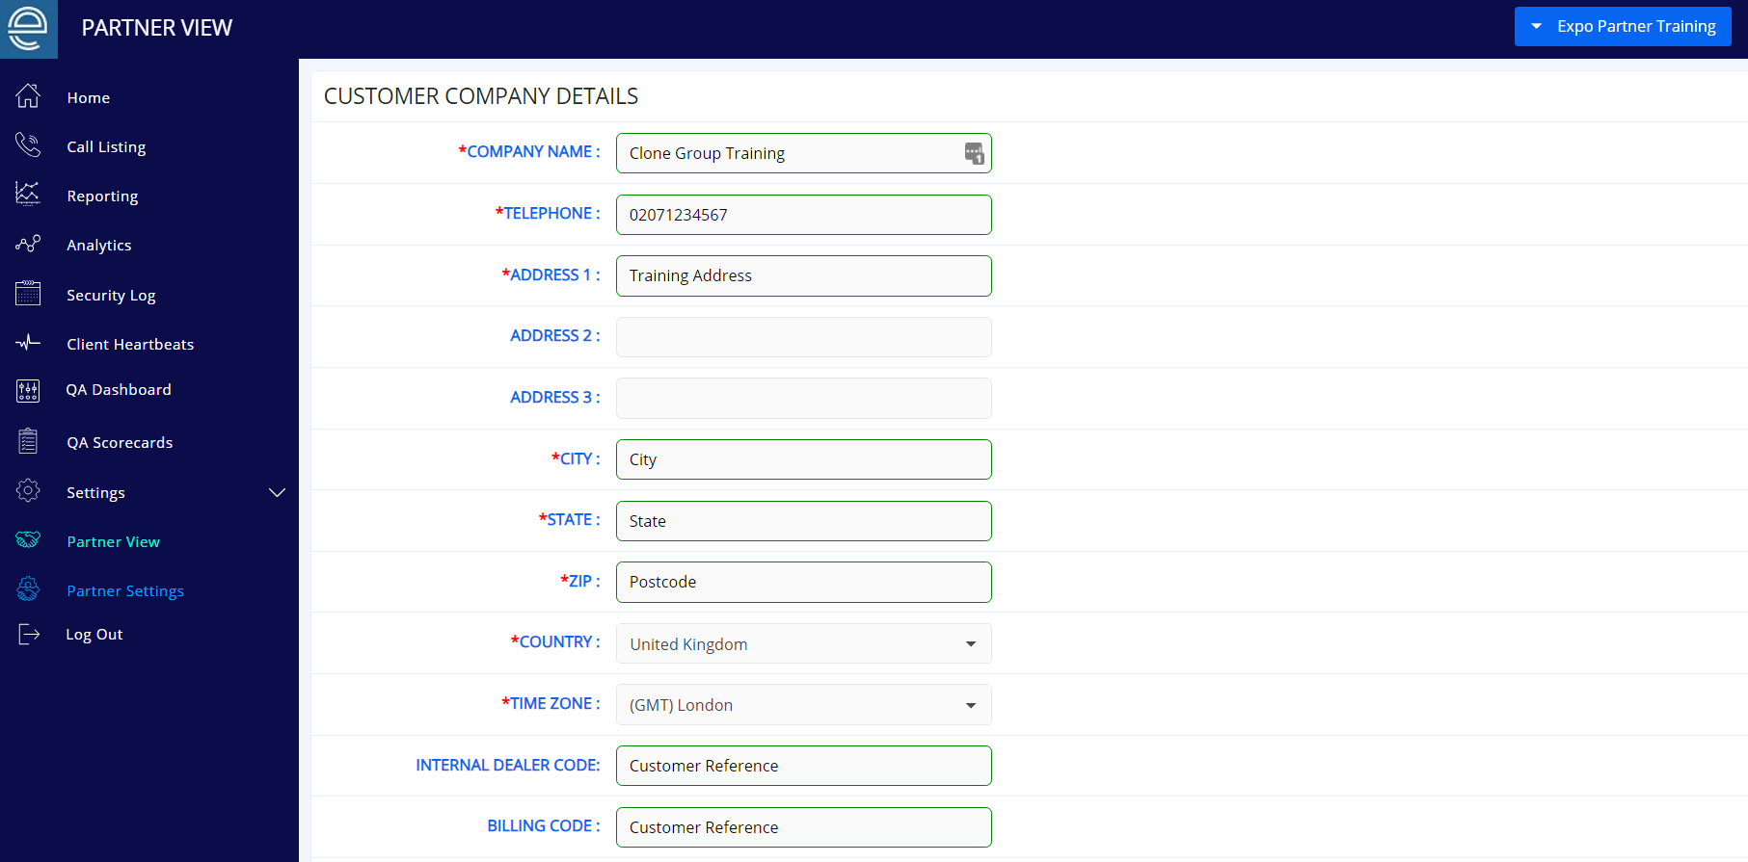

Enter the Partner Broadworks Group ID which has been created within the Partner Self Service Portal (this will be the unique group ID reference created when setting up the customer).
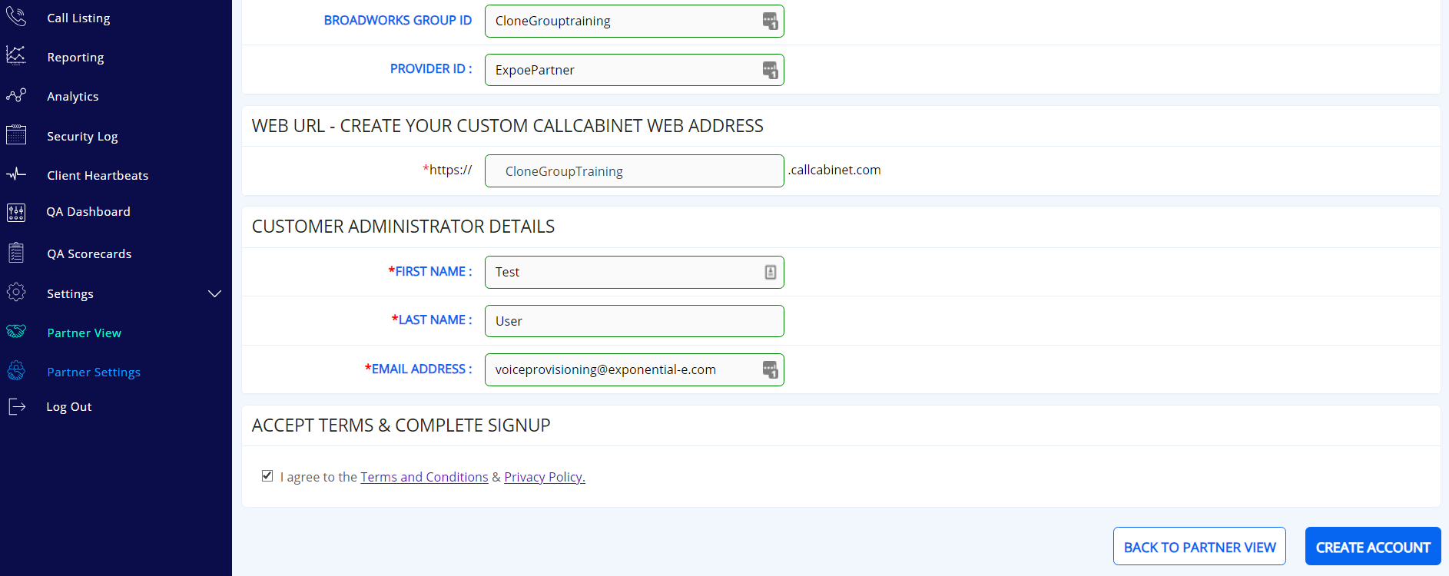
Then enter the Provider ID, which will be the Partner ID which was set up by EXPO.e within the Partner Self Service Portal.
.

This information can be found at the top of the login page within the Partner Self Service Portal as below.
Partner ID Customer ID
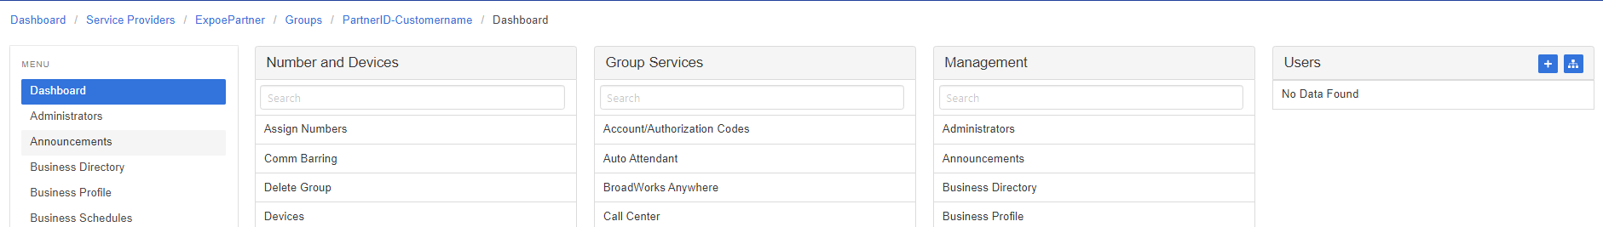

The Web URL will then auto populate.
Enter the customer administrator details of the admin user which will have access to Call Cabinet. This will then also send a welcome email to this email address with login details to Call Cabinet.
Lastly tick to accept the terms and click create account. The below ‘Registration Successful’ confirmation will then be displayed.
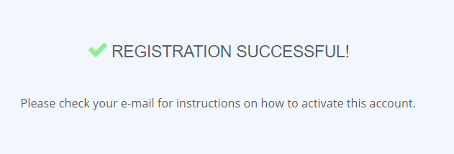

Once back on your Partner home page you the newly created customer will be visible under the Partner account.
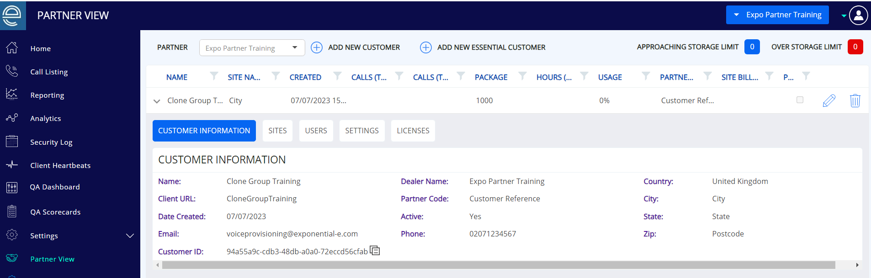

As this has now been created you can apply the call recording licenses to users within the Partner Self Service Portal and this will start recording once licenses have been applied.

Porting

High Level Porting Overview
In order to move numbers across from an existing service provider to EXPO.e, assistance will be required from the UC Provisioning Team in order to lodge port requests with the gaining carrier.
Number porting is supported in all countries that Exponential-e Group provides service. This covers geographic and non-geographic numbers.

Information Required (UK)
- Main billing number:
- Associated numbers/ranges:
- Registered address for the numbers/ranges:
- Loosing service provider:
- Range Holder:

How Long Does It Take?
Each product has a different lead-time, and these are subject to acceptance of the port.
- UK Analogue, Multi-Lines and ISDN - 22 working days from port acceptance
- Other European Countries - 20 working days from port acceptance
If the port is rejected, it is usually because of incomplete or inaccurate information. In this scenario the port will have to resubmitted with the revised, corrected information. The lead-time will start from when the re-submitted port is accepted.
Due to different technical and legal requirements in each country, the porting process can differ in different countries.

Risks
- Port order cancellations – Losing service providers can cancel a confirmed port up to 48 hours prior to the port date, resulting in the order being cancelled and the porting process to be started again.
- Inaccurate information – Inaccurate information can cause significant delays in the porting process.
- Once the numbers are ported local services such as alarm features, ADSL, fax machines, franking machines will be lost. At the point that the numbers port the physical service is ceased.
- On the day of porting, service may be lost for a period of time.

Contacts

Escalation Matrix
Level | Person | Contact Number | Email Address
0 - UC Provisioning Team | UC Provisioning Team | 020 7096 4049 | voiceprovisioning@exponential-e.com
1 – UC Provisioning Team Leader | Lydia Melen | 020 3435 8767 | Lydia.Melen@Exponential-e.com
2 – UC Provisioning Manager | Alan North | 020 3435 8775 | Alan.north@exponential-e.com
3 - Director of UC & Contact Centre Operations | Dan Baines-Holmes | 020 7096 4053 | Dan.Baines-Holmes@Exponential-e.com

