Sales Enablement Pack
Unified Communications as a Service
Let’s raise our voice together

Unified Communications as a Service (UCaaS) - Sales Enablement Pack

Innovations in communications

Our UCaaS service enables your customers to achieve superior collaboration and improve productivity at a competitive cost for them and with good margins for you. Our feature-rich and robust solution includes telephony, messaging, collaboration and meetings.
In partnership with EXPO.e, you can facilitate flexible, remote working practices for your customers, increasing their recruitment options and driving creative collaboration. This, in turn, will offer insights that help build deeper customer relationships and open the door to integrating AI and machine-learning into their business operations.

What is UCaaS with EXPO.e
The EXPO.e UCaaS offering provides a fully integrated experience that delivers one secure place to call, message, meet and get work done.

Calling
The most complete cloud phone system with powerful calling features across any device anywhere. Our Calling functions are deeply integrated within the UCaaS app. Publish one phone number and make or receive calls from a device of your choice.

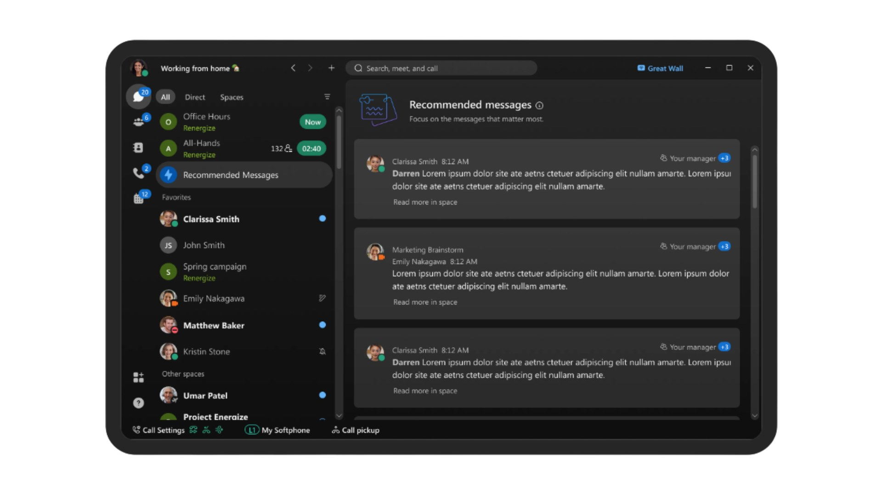
Messaging
Experience messaging that makes collaboration engaging and effortless. Features like file sharing, co-creation, sending messages, and whiteboard in easy-to-use spaces to collaborate securely, both inside and outside the company.
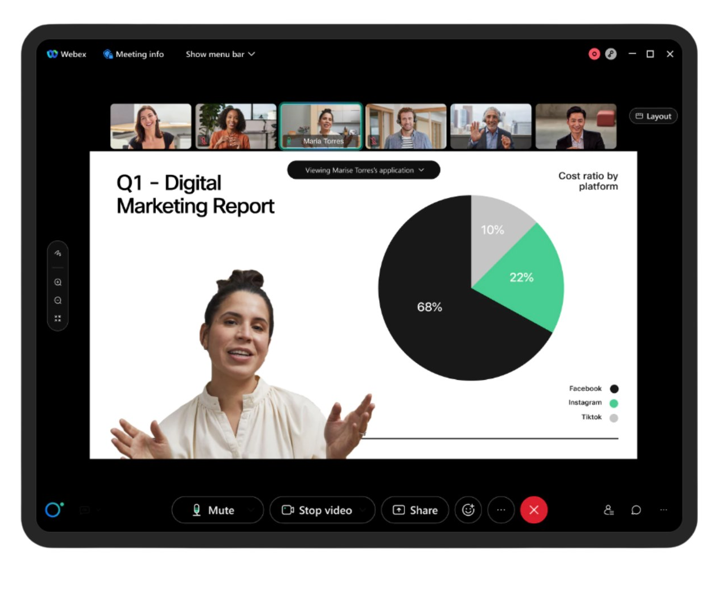

Meetings
Drive more engaging meetings. Ensure your meetings are designed to give everyone the ability to engage with benefiting from high quality video meetings built for teams, with a button to join meetings and seamless calendar integration.

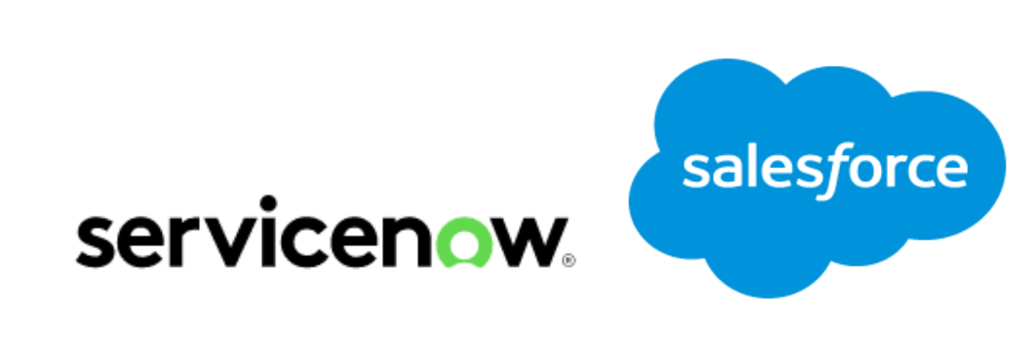
Integrations and Innovations
Connect the tools you use with UCaaS. With features such as self-service bots and add-ins, meeting schedulers for O365 and G-Suite, and integration with other tools, such as Salesforce and ServiceNow.

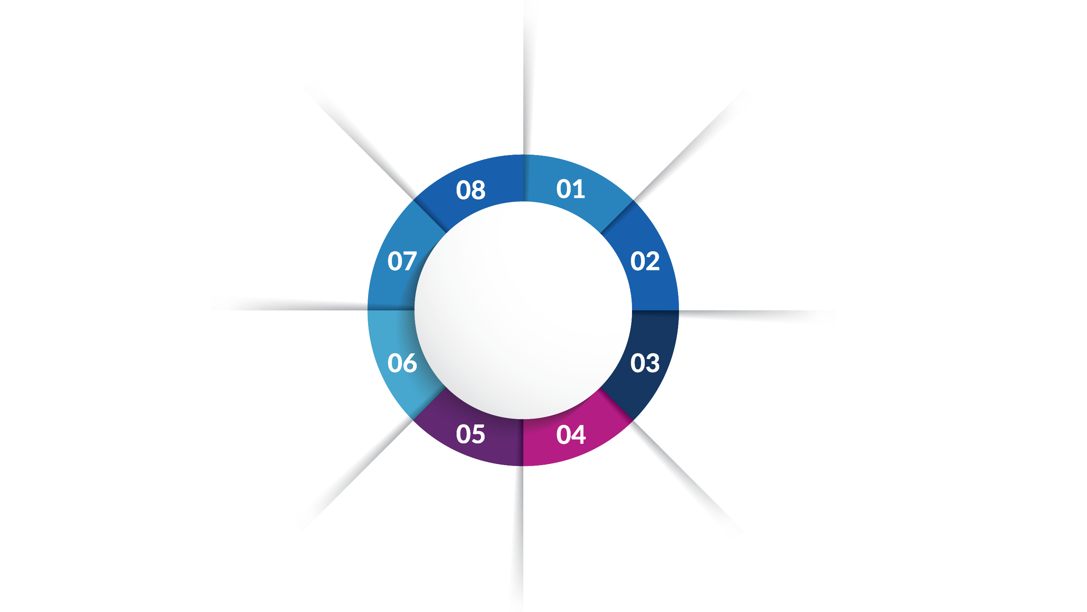
Key Benefits
Boost internal collaboration and workflow with persistent messaging for users and teams
Future proof your comms with enterprise-grade calling
Full PBX
Replacement with simple, easy-to-use Admin portal
Secure Collaboration from anywhere for both internally and externally
Integrate with business apps to improve efficiency and workflows
Seamless meeting experience for hybrid working or external meetings
End to End Management through EXPO.e connectivity
Tailor your deployment with a choice of headsets, handsets and soft clients

Market Information

63% of professionals spend more than two hours a day in meetings. Making meetings more efficient is key to boost their productivity.

By 2024, 3 out of 4 enterprise employees will not use a desk phone. It has more than doubled since 2020 when it was just 30%.

The global unified communications market is expected to grow at a CAGR of 24% in the forecast period of 2023 -2028

57% of SMBs plan to maintain remote working for employees as part of their new Hybrid Working policies.

Customer Challenges
- Less than 2 years left before the PTSN switch off in 2025.
- Legacy on-prem solutions are becoming end of life, leading customers to consider alternative solutions, which still fit their requirements.
- Inflexible software and hardware integrations for users both on site and remote.
- In today's hybrid world, the lack of key technologies in the workplace prevents employees from returning to the office and working effectively.
- Finding the right provider to assist with the cyber security and data concerns associated with hybrid working and cloud communications.
- Many businesses use several apps to bring together a UCC solution, which is harder to monitor, and manage as a result, this delivers a poor user experience.

Why EXPO.e for UCaaS
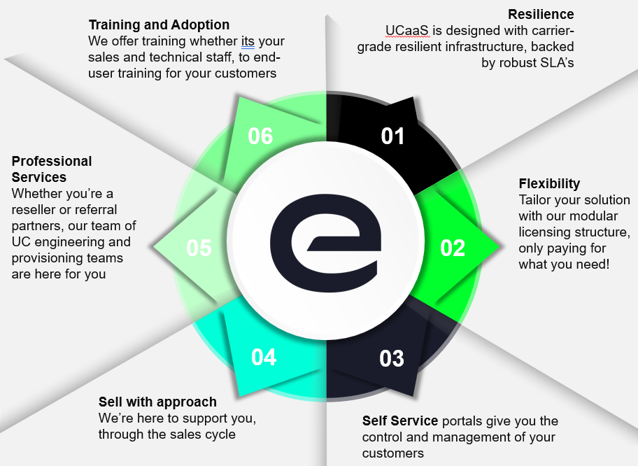

Features & Benefits
- Simple video-first experiences from any device - Collaborate effectively with customers, partners and colleagues with integrated video, voice and content sharing.
- Connect securely - From anywhere on any device -desktop, mobile, web, video devices – with an easy, consistent experience.
- Integration wherever you work using tools you love - UCaaS service provides deep integrations with leading productivity tools, including Microsoft Teams, Slack, Salesforce and many others.
- Industry leading security and compliance - EXPO.e UCaaS service is built with leading industry expertise, which helps ensure speed and performance. Our customers get secure, high-quality collaboration tools without compromise. Our UCaaS Service provides the highest level of protection for meeting data with support for AES 256-Bit GCM Encryption.
- Direct and team chats screensharing, emoji’s and GIPHYS - With one click, easy to join meetings and simple file sharing to name a few for easy and simple collaboration.
- Fully resilient service with 99.99% SLA - UCaaS platform built within geographically diverse Data Centres – providing end users with always-on inbound/outbound calling functionality, driving productivity and responsiveness.
- Save time - Reducing the time spent by internal IT teams managing and supporting telephony systems or multiple disjointed UCC applications.
- Fully managed solution - Our on-going 24/7 management and support from UCC specialists completely removes the IT burden from the customer's internal team to make more effective use of resources.
- Customer Portal - Provides visibility of the customer estate and enable customers to perform basic modifications to their existing estate.
- Simple Instant Messaging - Allows users to privately message one person or create group chat in seconds, allowing users to communicate faster and have a higher engagement rate.
- Noise removal with UCaaS technology - Lets customers meet with confidence and take the difficulty out of conferencing no matter where they are working.
- Reach a wider audience – Customers can hold meetings of up to 1,000 participants, make their business more accessible for employees and customers, by erasing geographical barriers, and reach your business goals to achieve their desired outcomes.
- Share content safely – Allowing customers to focus on building and delivering meaningful artifacts to end users in shared spaces.

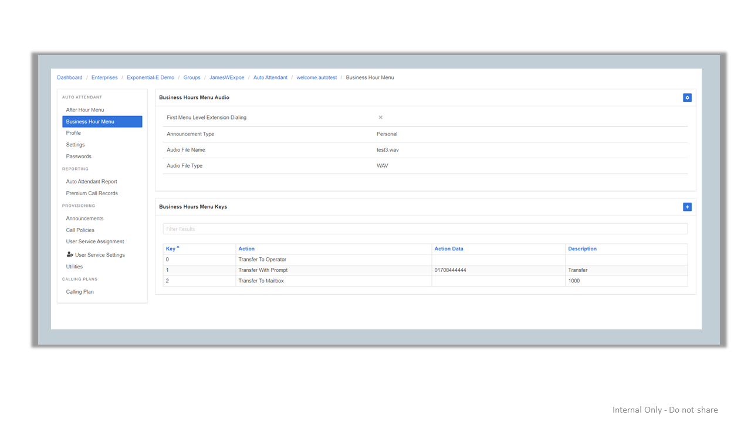
Product Add-Ons

Auto-attendant
Auto-attendant used to greet, queue and direct calls on the basis of user input. Inbound callers can be held in a queue if it is not possible to route their call based on menu selection.
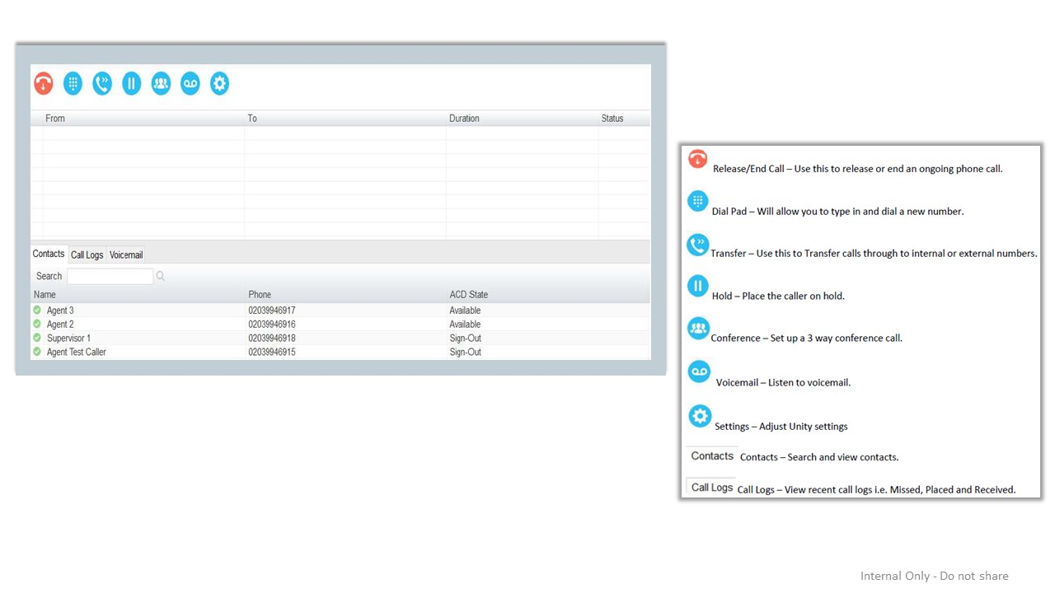

Attendant Console
Attendant Console enables receptionists to manage inbound calls and perform a variety of functions relating to incoming calls within an enterprise.

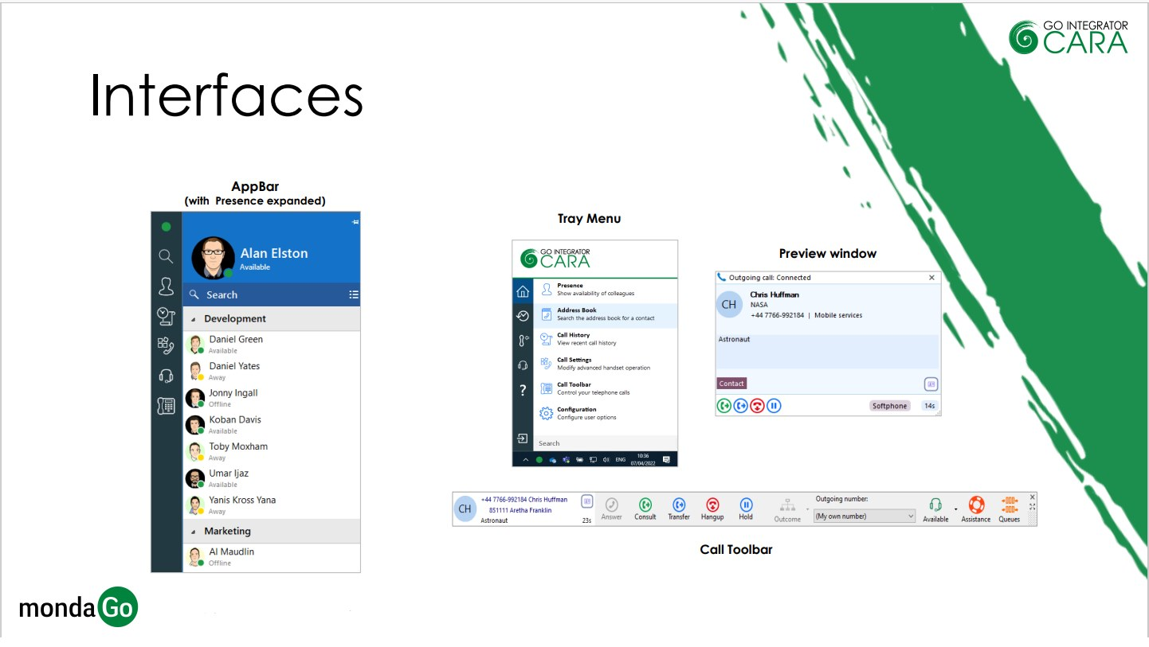
Go Integrator Cara
Go Integrator Cara is a Unified Communications client, designed for users to make optimal use of their UCaaS hosted telephony platform.
Cara provides integration to contact-orientated business systems and CRM applications, offering our customers a standard set of integration features with over 250 popular cross-vertical and vertical-spec applications. Cara provides significant productivity gains, including rapid caller identification via on screen pop-ups and quick dialling tools for highly efficient call processing.

Use Cases

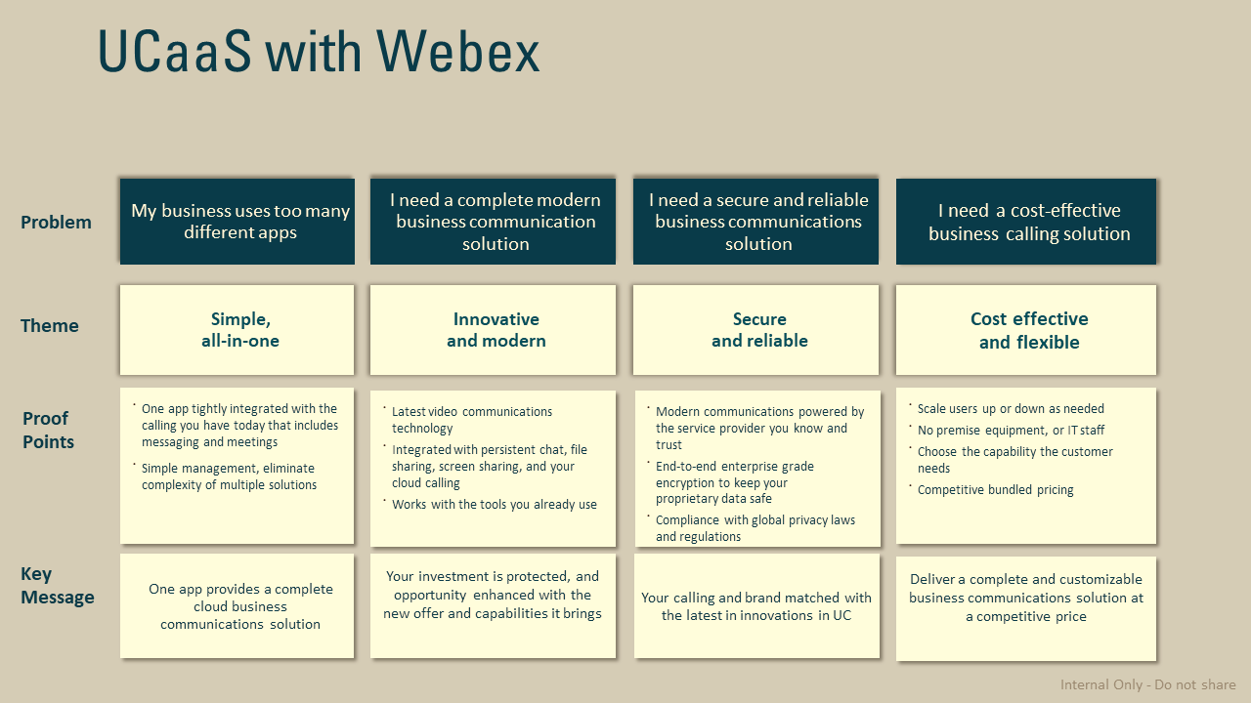

Discovery questions to ask your customer
- Is your business as responsive to your customers, prospects, and partners as it needs to be, or are you still using outdated communications and collaboration technology?
- How does your company currently communicate with one another, customers, vendors, and business partners? Does this change much for different teams?
- Has the organisation adopted a hybrid working policy? Do you have remote workers? Multiple sites? Users on the move? How do you guarantee every user collaborates effectively regardless of location?
- Has your business moved the phone system to the cloud, or are you still using an on-prem PBX? If that's the case, what do you see as the leading reasons for not adopting a cloud communications service yet? If you already have a cloud communications service, has your cloud provider been living up to your expectations?
- Is your UCC System fully serving your business objectives? Is it well integrated with employee smartphones? How about your calendar and email platforms? Do your employees feel as productive and reachable when mobile as they do when they’re in the office?
- Have you thought about adopting cloud services for business voice, meetings, and team collaboration? What kind of timeline do you see in moving these services to the cloud?
- How important is it to avoid future disruptions from acts of nature and other similar events? How robust is your on-prem solution? If you have a cloud communications service, is it fully resilient?
- Does your IT staff have enough bandwidth to focus on new, strategic initiatives that propel your business forward, or do they have to spend most of their time dealing with issues related to the phone system or disjointed communication applications?
- What do you use for messaging in the workplace? How about video conferencing? How easy is it to include external participants in your meetings?
- How many different applications do you use to manage your UCC (chat, calls, video, sharing...), are they fully integrated?
- Are you aware of the impact of your current UCC solution to your Cyber Security posture? Are you confident that your data is protected and always stays private?

Qualification questions to ask your customer
- Is the business geographically dispersed? What countries require PSTN breakout?
- How many employees do you have in your business? Remote users? Hybrid working policy?
- Do you need collaborate regularly with partners or customers? How do you communicate with them currently?
- What is the current volume of voice minutes? Any destinations to highlight?
- Does the customer have a particular vendor strategy? Do they have a multi-vendor strategy?
- Does the customer have a Contact Centre strategy?
- What are the customer's feature requirements? Do they require the below features?
- Receptionist Handset/Console
- Alternate numbers
- Audio/Video calling
- Call centre login/log out
- Call Recording
- Auto Attendant
- What does the customer currently do for video/audio meetings, and do they have legacy hardware?
- Do they currently have Virtual Meeting Rooms that are Cloud-based?
- Do they have or need Physical Video/Audio systems that need to be included in their solution?
- What is the largest expected meeting in terms of number of participants?

